26 March, 2026

PRESS RELEASE

SUPPLY, USE AND INPUT-OUTPUT TABLES: 2022

Total Supply and Use at Purchasers’ Prices for the year 2022, Balanced at €96.658,5 mn

The Statistical Service announces the publication of the Supply, Use and Input-Output tables of Cyprus, for the year 2022 in current prices and in previous year prices. It is noted that the data for the years 2018-2021 has been revised.

For the year 2022, total supply and use at purchasers’ prices are balanced at €96.658,5 mn. Business services account for 48,4% of total supply, followed by manufacturing products 25,1% and distribution & transport services 10,5%. The share of other services in total supply is 8,4%, of construction works 6,2% and of agriculture, forestry & fishing products 1,4%. (Figure 1)

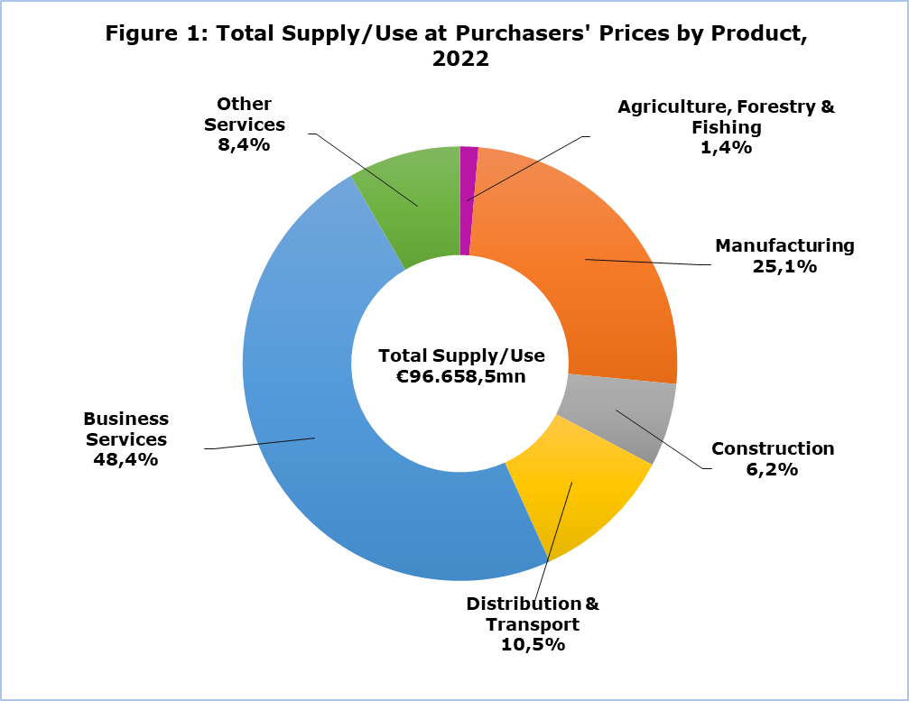

The table 1 below presents an aggregated version of the 2022 Supply table at current prices. Total domestic production in basic prices is €64.381,7 mn in 2022, total imports €28.932,0 mn and net taxes on products €3.344,8 mn.
Table 1: Supply, 2022 €mn
Product Categories (CPA) | Domestic Production | Imports | Trade Margins | Net Taxes on Products | Total Supply (purchasers' prices)
Agriculture, forestry & fishing (CPA 01-03) | 840,5 | 324,4 | 123,0 | 22,4 | 1.310,2
Manufacturing (CPA 05-39) | 6.688,2 | 11.619,6 | 4.159,0 | 1.834,3 | 24.301,0
Construction (CPA 41-43) | 5.454,7 | 3,7 | 0,0 | 549,3 | 6.007,7
Distribution & transport (CPA 45-53) | 11.788,6 | 2.713,1 | -4.331,9 | 4,1 | 10.173,8
Business services (CPA 55-82) | 31.954,0 | 13.924,8 | 49,9 | 834,2 | 46.762,9
Other services (CPA 84-99) | 7.655,8 | 346,5 | 0,0 | 100,5 | 8.102,9
Total Supply (CPA 01-99) | 64.381,7 | 28.932,0 | 0,0 | 3.344,8 | 96.658,5

The domestic production accounts for 66,6% of total supply, imports for 29,9% and net taxes for 3,5%. Imports have a particularly large share (47,8%) of total supply of manufacturing products. Net taxes on products have a higher share in the supply of construction works (9,1%) and manufacturing products (7,6%), than in the other product categories. (Figure 2)

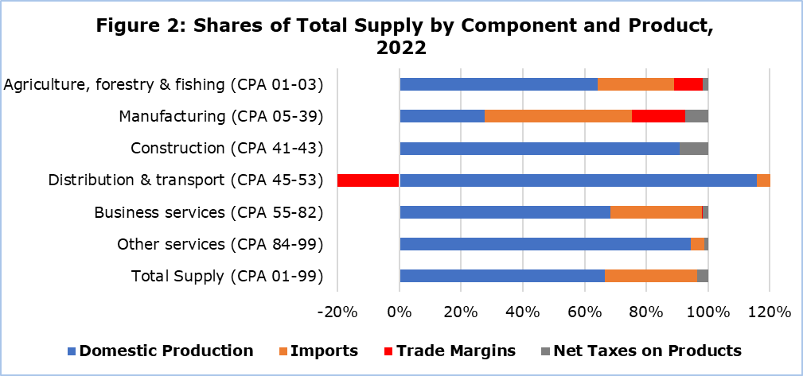

The following table 2 presents an aggregated version of the 2022 Use table at current prices. Total intermediate consumption is €38.081,2 mn in 2022. Total final consumption is €23.965,8 mn, gross capital formation is valued at €6.105,5 mn and total exports at €28.506,1 mn.

Table 2: Use, 2022 €mn
Product Categories (CPA) | Intermediate Consumption | Final Consumption | Gross Capital Formation | Exports | Total Use (purchasers' prices)
Agriculture, forestry & fishing (CPA 01-03) | 673,7 | 543,2 | -13,3 | 106,7 | 1.310,2
Manufacturing (CPA 05-39) | 9.514,1 | 7.958,3 | 1.732,9 | 5.095,7 | 24.301,0
Construction (CPA 41-43) | 2.614,5 | 13,3 | 3.335,5 | 44,4 | 6.007,7
Distribution & transport (CPA 45-53) | 4.357,4 | 835,6 | 0,0 | 4.980,9 | 10.173,8
Business services (CPA 55-82) | 20.336,1 | 7.478,1 | 1.034,9 | 17.913,8 | 46.762,9
Other services (CPA 84-99) | 585,3 | 7.137,3 | 15,5 | 364,7 | 8.102,9
Total Use (CPA 01-99) | 38.081,2 | 23.965,8 | 6.105,5 | 28.506,1 | 96.658,5

Intermediate consumption has the largest share (39,4%) in total use. The second largest share of total use is exports (29,5%), followed by final consumption (24,8%) and gross capital formation (6,3%). Intermediate consumption makes up the majority of total use of agriculture, forestry and fishing products (51,4%), manufacturing products (39,2%) and business services (43,5%). Final consumption is the main use of other services (88,1%), with the rest distributed mostly between intermediate consumption and exports. The supply of construction works is mostly used as gross capital formation (55,5%), closely followed by intermediate consumption (43,5%). Distribution and transport services are mostly exported (49,0%), with their next most important use being intermediate consumption (42,8%). (Figure 3)

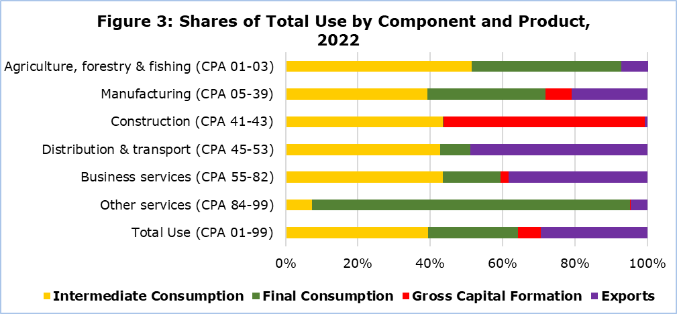

The Gross Value Added (GVA) at basic prices is calculated by deducting intermediate consumption at purchasers’ prices from domestic production at basic prices. To reach the Gross Domestic Product (GDP) at market prices, taxes less subsidies on products are added to GVA at basic prices.

Domestic Production |  | Intermediate Consumption |  | Gross Value Added |  | Taxes less Subsidies on Products |  | Gross Domestic Product
64.381,7 | - | 38.081,2 | = | 26.300,6 | + | 3.344,8 | = | 29.645,4

METHODOLOGICAL INFORMATION

General Information

The Supply, Use and Input-Output Tables are an important part of the System of National Accounts, as they provide detailed information for the analysis of the transactions of goods and services by industries and consumers in the economy. The tables are matrices by product type and industry, describing how domestic production and imports are used for intermediate consumption and final uses.

The tables are published annually, no later than three years after the end of the reference year, in accordance with the provisions of Regulation (EU) No 549/2013.

Data Coverage and Collection

The tables cover the entire economy, including all institutional sectors, all products and types of economic activity. The economic operations with the rest of the world are also recorded.

The production of the SUIOT is based mainly on the results of the annual economic surveys of the Statistical Service of Cyprus, administrative sources, Government Finance Statistics and any data adjustments according to the European System of Accounts 2010 (ESA 2010).

For more information:
CYSTAT Portal, subtheme National Accounts
CYSTAT-DB (Online Database)
Methodological information

Contacts
Michalis Charalambous: Tel.: +357-22602136, E-mail: micharalambous@cystat.mof.gov.cy
Demetris Ioannou: Tel.: +357-22605128, E-mail: dioannou@cystat.mof.gov.cy

