19 May, 2025

**PRESS RELEASE**

###### TOURIST ARRIVALS AND RETURNS OF RESIDENTS OF CYPRUS FROM TRIPS ABROAD: APRIL 2025

**Tourist Arrivals 25,5% and Returns of Residents of Cyprus 24,1%**

**Tourist Arrivals**

The arrivals of tourists reached 418.730 in April 2025 compared to 333.563 in April 2024, recording an increase of 25,5%.

For the period of January – April 2025, arrivals of tourists totaled 865.326 compared to 748.814 in the corresponding period of 2024, recording an increase of 15,6%.

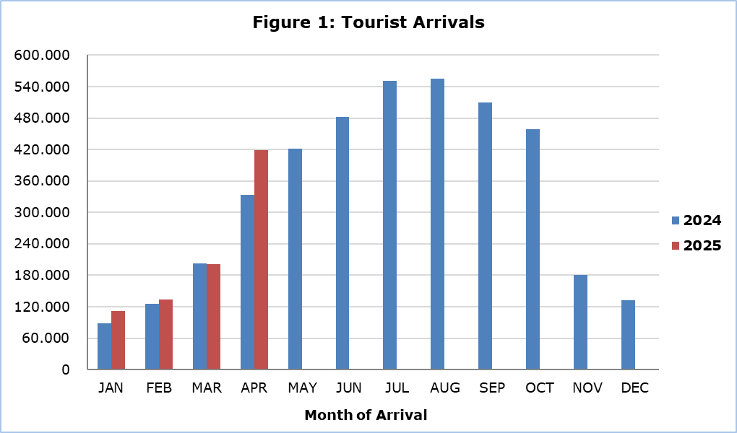

Arrivals from the United Kingdom were the main source of tourism for April 2025, with a share of 36,3% (151.883) of total arrivals, followed by Israel with 15,2% (63.474), Germany with 7,1% (29.613), Poland with 6,9% (29.009) and Greece with 3,9% (16.354) (Table 1).

|  |  |  |  |  |
| --- | --- | --- | --- | --- |
| **Table 1** |  | | | |
| **Country of Usual Residence** | **Tourist Arrivals** | | | |
| **April** | | | **Percentage Change**  **(%)**  **Apr. 2025/24** |
| **2023** | **2024** | **2025** |
| **TOTAL** | **342.736** | **333.563** | **418.730** | **25,5** |
| Austria | 6.883 | 4.531 | 7.126 | 57,3 |
| France | 6.380 | 11.984 | 8.113 | -32,3 |
| Germany | 23.038 | 22.510 | 29.613 | 31,6 |
| Denmark | 4.430 | 5.171 | 5.516 | 6,7 |
| Switzerland | 6.082 | 6.475 | 6.647 | 2,7 |
| Greece | 21.184 | 13.056 | 16.354 | 25,3 |
| United Kingdom | 124.455 | 117.902 | 151.883 | 28,8 |
| Israel | 34.069 | 35.673 | 63.474 | 77,9 |
| Lebanon | 3.735 | 3.203 | 2.776 | -13,3 |
| Norway | 3.057 | 3.853 | 3.957 | 2,7 |
| Netherlands | 5.858 | 5.131 | 8.810 | 71,7 |
| Hungary | 5.301 | 3.284 | 4.394 | 33,8 |
| Poland | 23.063 | 25.250 | 29.009 | 14,9 |
| Romania | 8.077 | 6.176 | 8.357 | 35,3 |
| Sweden | 12.791 | 12.011 | 13.967 | 16,3 |
| Other | 54.331 | 57.353 | 58.734 | 2,4 |

For a percentage of 80,3% of tourists, the purpose of their trip in April 2025 was holidays, for 12,7% visit to friends and relatives and for 6,9% business. Respectively, in April 2024, 82,1% of tourists visited Cyprus for holidays, 9,4% visited friends or relatives and 8,3% visited Cyprus for business reasons (Table 2).

|  |  |  |  |
| --- | --- | --- | --- |
| **Table 2** |  |  |  |
| **Purpose of Visit** | **Percentage (%)** | | |
| **Apr. 2023** | **Apr. 2024** | **Apr. 2025** |
| Holidays | 79,3 | 82,1 | 80,3 |
| Visiting friends & relatives | 14,5 | 9,4 | 12,7 |
| Business | 6,0 | 8,3 | 6,9 |

**Returns of Residents of Cyprus**

A total number of 164.844 residents of Cyprus returned from a trip abroad in April 2025 compared to 132.806 in the corresponding month last year, recording an increase of 24,1%.

The main countries from which residents of Cyprus returned in April 2025 were Greece with a share of 33,3% (54.967), the United Kingdom with 8,6% (14.111) and Italy with 6,5% (10.735).

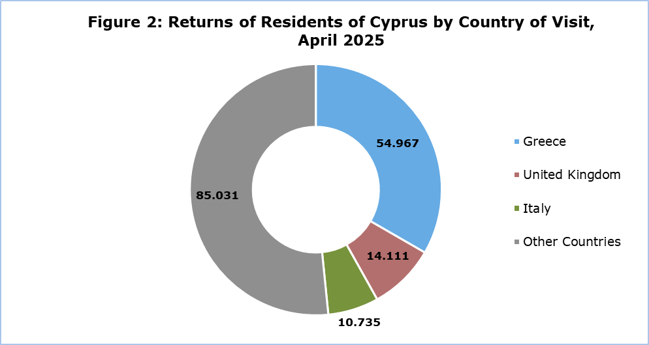

The purpose of travel for the residents of Cyprus in April 2025 was mainly holidays, with a percentage of 70,9%, whilst business reasons held a percentage of 17,5%, studies 10,8% and other reasons 0,8%.

**METHODOLOGICAL INFORMATION**

**Definitions**

**Tourists** – Visitors who stay for at least one night in Cyprus.

**Tourist arrivals** – The term refers to the number of trips and not to the number of persons. This differs in the sense that one person can take more than one trips during the reference period.

**Residents of Cyprus -** This category includes persons who have resided in Cyprus for at least 12 months or who have come to Cyprus with the intention of staying for at least 12 months, prior to their travel.

**Source of Data and Coverage**

The data are obtained from the Passengers Survey which is carried out at the points of arrival in Larnaka and Pafos airports. Additionally, data are also collected from administrative sources, such as the monthly arrivals from ports.

The data covers all persons who pass through passport control at the ports and airports in the Government controlled area of Cyprus. It does not include travelers who arrive and depart illegally via ports and airports in the occupied part of Cyprus.

The weighting was conducted based on the data sent to the Statistical Service by the Civil Aviation Department and from the ship manifests, as well as on the data sent by the Analysis and Statistics Office of the Cyprus Police.

***For more information:***

CYSTAT Portal, subtheme [Tourism](https://www.cystat.gov.cy/en/SubthemeStatistics?s=51)

[CYSTAT-DB](https://cystatdb.cystat.gov.cy/pxweb/en/8.CYSTAT-DB/8.CYSTAT-DB__Tourism__) (Online Database)

[Predefined Tables](https://www.cystat.gov.cy/en/KeyFiguresList?s=51) (Excel)

[Methodological Information](https://www.cystat.gov.cy/en/MethodologicalDetails?m=2172)

**The Predefined Tables available in Excel format, include data up to December 2024. As of January 2025, data will only be available in the Online Database CYSTAT-DB.**

*Contact*

Lucy Panayidou: Tel.: +35722602152, E-mail: [lpanagidou@cystat.mof.gov.cy](mailto:lpanagidou@cystat.mof.gov.cy)