19 January, 2026

PRESS RELEASE

TOURIST ARRIVALS AND RETURNS OF RESIDENTS OF CYPRUS FROM TRIPS ABROAD: DECEMBER 2025

Tourist Arrivals 18,0% and Returns of Residents of Cyprus 14,9%

Tourist Arrivals

The arrivals of tourists reached 156.959 in December 2025 compared to 133.063 in December 2024, recording an increase of 18,0%.

For the period of January – December 2025, arrivals of tourists totaled 4.534.073 compared to 4.040.200 in the corresponding period of 2024, recording an increase of 12,2%.

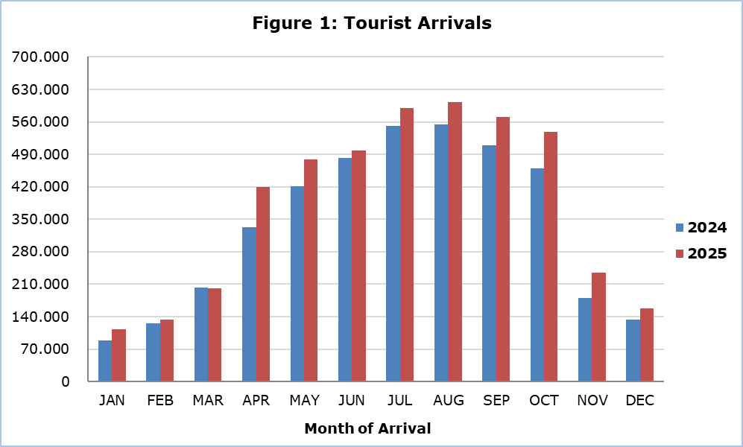

Arrivals from Israel were the main source of tourism for December 2025, with a share of 19,1% (30.020) of total arrivals, followed by the United Kingdom with 19,0% (29.826), Poland with 11,3% (17.779), Germany with 7,4% (11.569) and Greece with 7,3% (11.413) (Table 1).

Table 1
Country of Usual Residence | Tourist Arrivals
Country of Usual Residence | December |  |  | Percentage Change  (%)  Dec. 2025/24
Country of Usual Residence | 2023 | 2024 | 2025 | Percentage Change  (%)  Dec. 2025/24
TOTAL | 123.630 | 133.063 | 156.959 | 18,0
Austria | 1.067 | 1.708 | 2.353 | 37,8
France | 2.857 | 1.315 | 2.046 | 55,6
Germany | 6.259 | 7.535 | 11.569 | 53,5
Denmark | 326 | 682 | 663 | -2,8
Switzerland | 1.733 | 1.476 | 1.661 | 12,5
Greece | 12.792 | 11.969 | 11.413 | -4,6
United Kingdom | 28.973 | 31.501 | 29.826 | -5,3
Israel | 11.109 | 23.168 | 30.020 | 29,6
Lebanon | 2.699 | 1.372 | 1.633 | 19,0
Norway | 756 | 576 | 385 | -33,2
Netherlands | 1.347 | 2.321 | 2.718 | 17,1
Hungary | 1.794 | 533 | 969 | 81,8
Poland | 14.233 | 12.473 | 17.779 | 42,5
Romania | 3.443 | 2.589 | 4.183 | 61,6
Sweden | 1.343 | 1.881 | 1.889 | 0,4
Other | 32.899 | 31.964 | 37.852 | 18,4

In December 2025, 56,4% of tourists travelled for holidays, 32,0% visited friends and relatives and 11,3% travelled for business purposes. Respectively, in December 2024, 49,6% of tourists visited Cyprus for holidays, 37,5% visited friends or relatives and 12,7% visited Cyprus for business purposes (Table 2).

Table 2
Purpose of Visit | Percentage (%)
Purpose of Visit | Dec. 2023 | Dec. 2024 | Dec. 2025
Holidays | 58,4 | 49,6 | 56,4
Visiting friends & relatives | 30,4 | 37,5 | 32,0
Business | 11,0 | 12,7 | 11,3

Returns of Residents of Cyprus

A total of 193.007 residents of Cyprus returned from a trip abroad in December 2025 compared to 168.022 in the corresponding month last year, recording an increase of 14,9%.

The main countries from which residents of Cyprus returned in December 2025 were Greece with a share of 28,4% (54.759), the United Kingdom with 11,0% (21.224) and Poland with 6,5% (12.554).

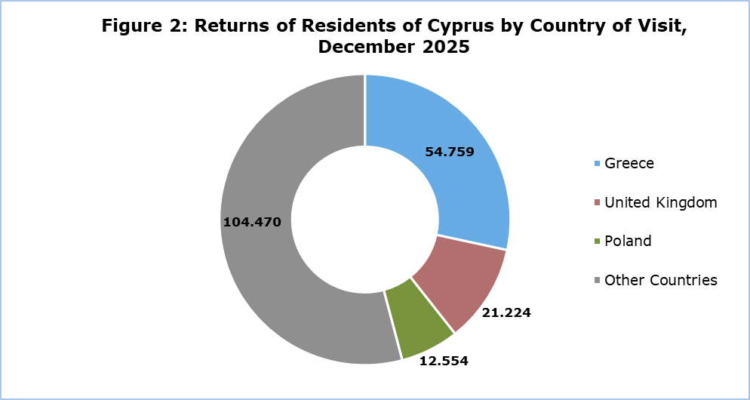

The purpose of travel for the residents of Cyprus in December 2025 was mainly holidays, with a percentage of 69,3%, whilst business reasons held a percentage of 14,9%, studies 15,0% and other reasons 0,8%.

METHODOLOGICAL INFORMATION

Definitions

Tourists – Visitors who stay for at least one night in Cyprus.

Tourist arrivals – The term refers to the number of trips and not to the number of persons. This differs in the sense that one person can take more than one trip during the reference period.

Residents of Cyprus - This category includes persons who have resided in Cyprus for at least 12 months or who have come to Cyprus with the intention of staying for at least 12 months, prior to their travel.

Source of Data and Coverage

The data are obtained from the Passengers Survey which is carried out at the points of arrival in Larnaka and Pafos airports. Additionally, data are also collected from administrative sources, such as the monthly arrivals from ports.

The data covers all persons who pass through passport control at the ports and airports in the Government controlled area of Cyprus. It does not include travelers who arrive and depart illegally via ports and airports in the occupied part of Cyprus.

The weighting was conducted based on the data sent to the Statistical Service by the Civil Aviation Department and from the ship manifests, as well as on the data sent by the Analysis and Statistics Office of the Cyprus Police.

For more information:
CYSTAT Portal, subtheme Tourism
CYSTAT-DB (Online Database)
Predefined Tables (Excel)
Methodological Information

The Predefined Tables available in Excel format, include data up to December 2024. As of January 2025, data will only be available in the Online Database CYSTAT-DB.

Contact
Lucy Panayidou: Tel.: +357-22602152, E-mail: lpanagidou@cystat.mof.gov.cy

