17 March, 2025

PRESS RELEASE

TOURIST ARRIVALS AND RETURNS OF RESIDENTS OF CYPRUS FROM TRIPS ABROAD: FEBRUARY 2025

Tourist Arrivals 7,0% and Returns of Residents of Cyprus 8,9%

Tourist Arrivals

The arrivals of tourists reached 133.760 in February 2025 compared to 125.034 in February 2024, recording an increase of 7,0%.

For the period of January – February 2025, arrivals of tourists totaled 245.860 compared to 212.995 in the corresponding period of 2024, recording an increase of 15,4%.

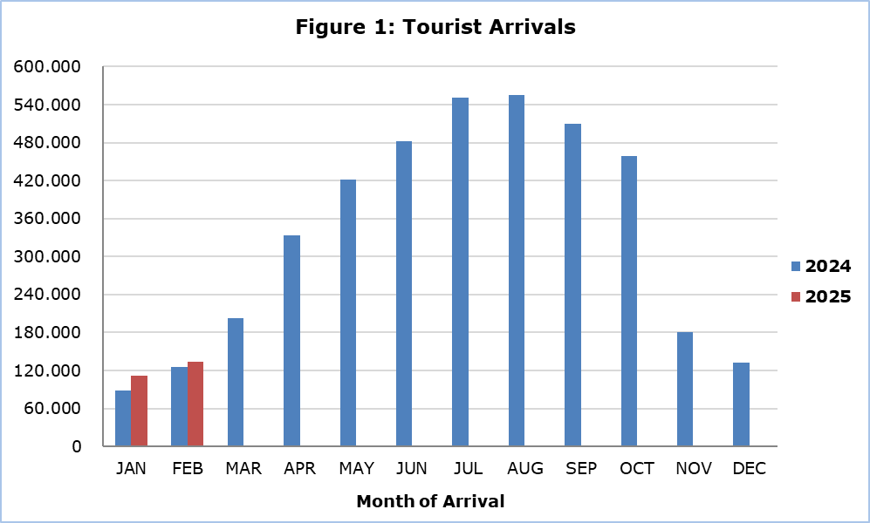

Arrivals from the United Kingdom were the main source of tourism for February 2025, with a share of 24,8% (33.115) of total arrivals, followed by Poland with 15,1% (20.165), Israel with 14,3% (19.194) and Greece with 8,2% (10.978) (Table 1).

Table 1
Country of Usual Residence | Tourist Arrivals
Country of Usual Residence | February |  |  | Percentage Change  (%)  Feb. 2025/24
Country of Usual Residence | 2023 | 2024 | 2025 | Percentage Change  (%)  Feb. 2025/24
TOTAL | 119.081 | 125.034 | 133.760 | 7,0
Austria | 1.819 | 2.178 | 1.957 | -10,1
France | 2.242 | 3.928 | 1.796 | -54,3
Germany | 6.107 | 7.359 | 8.093 | 10,0
Denmark | 614 | 785 | 669 | -14,8
Switzerland | 653 | 1.208 | 1.231 | 1,9
Greece | 15.058 | 12.835 | 10.978 | -14,5
United Kingdom | 32.394 | 30.774 | 33.115 | 7,6
Israel | 15.196 | 13.290 | 19.194 | 44,4
Lebanon | 1.675 | 1.905 | 1.918 | 0,7
Norway | 118 | 935 | 800 | -14,4
Netherlands | 1.411 | 1.536 | 2.238 | 45,7
Hungary | 1.110 | 1.720 | 659 | -61,7
Poland | 11.728 | 16.591 | 20.165 | 21,5
Romania | 3.157 | 2.011 | 2.424 | 20,5
Sweden | 1.070 | 644 | 1.488 | 131,1
Other | 24.729 | 27.335 | 27.035 | -1,1

For a percentage of 60,3% of tourists, the purpose of their trip in February 2025 was holidays, for 20,4% visit to friends and relatives and for 19,1% business. Respectively, in February 2024, 66,8% of tourists visited Cyprus for holidays, 17,8% visited friends or relatives and 14,2% visited Cyprus for business reasons (Table 2).

Table 2
Purpose of Visit | Percentage (%)
Purpose of Visit | Feb. 2023 | Feb. 2024 | Feb. 2025
Holidays | 66,7 | 66,8 | 60,3
Visiting friends & relatives | 20,1 | 17,8 | 20,4
Business | 13,0 | 14,2 | 19,1

Returns of Residents of Cyprus

A total number of 124.232 residents of Cyprus returned from a trip abroad in February 2025 compared to 114.110 in the corresponding month last year, recording an increase of 8,9%.

The main countries from which residents of Cyprus returned in February 2025 were Greece with a share of 34,4% (42.733), the United Kingdom with 9,5% (11.825), Italy with 5,1% (6.289), United Arab Emirates with 4,0% (5.028) and Germany with 3,4% (4.237).

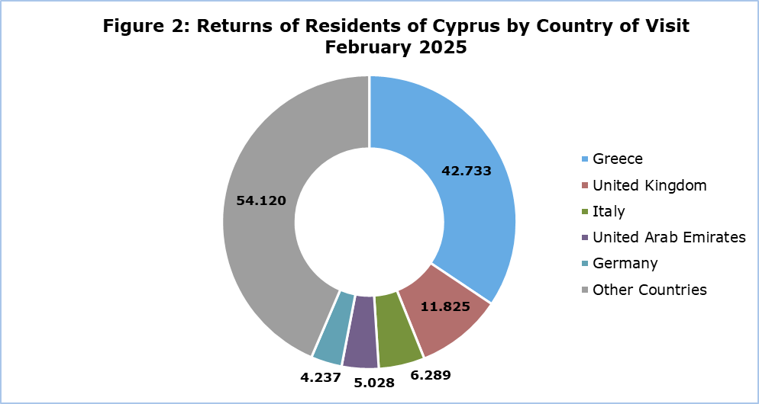

The purpose of travel for the residents of Cyprus in February 2025 was mainly holidays, with a percentage of 71,9%, whilst business reasons held a percentage of 24,3%, studies 2,8% and other reasons 1,0%.

METHODOLOGICAL INFORMATION

Definitions

Tourists – Visitors who stay for at least one night in Cyprus.

Tourist arrivals – The term refers to the number of trips and not to the number of persons. This differs in the sense that one person can take more than one trips during the reference period.

Residents of Cyprus - This category includes persons who have resided in Cyprus for at least 12 months or who have come to Cyprus with the intention of staying for at least 12 months, prior to their travel.

Source of Data and Coverage

The data are obtained from the Passengers Survey which is carried out at the points of arrival in Larnaka and Pafos airports. Additionally, data are also collected from administrative sources, such as the monthly arrivals from ports.

The data covers all persons who pass through passport control at the ports and airports in the Government controlled area of Cyprus. It does not include travelers who arrive and depart illegally via ports and airports in the occupied part of Cyprus.

The weighting was conducted based on the data sent to the Statistical Service by the Civil Aviation Department and from the ship manifests, as well as on the data sent by the Analysis and Statistics Office of the Cyprus Police.

For more information:
CYSTAT Portal, subtheme Tourism
CYSTAT-DB (Online Database)
Predefined Tables (Excel)
Methodological Information

The Predefined Tables available in Excel format, will include data up to December 2024. As of February 2025, data will only be available in the Online Database CYSTAT-DB.

Contact
Lucy Panayidou: Tel.: +35722602152, E-mail: lpanagidou@cystat.mof.gov.cy

