17 February, 2026

PRESS RELEASE

TOURIST ARRIVALS AND RETURNS OF RESIDENTS OF CYPRUS FROM TRIPS ABROAD: JANUARY 2026

Tourist Arrivals 8,5% and Returns of Residents of Cyprus 15,0%

Tourist Arrivals

The arrivals of tourists reached 121.625 in January 2026 compared to 112.100 in January 2025, recording an increase of 8,5%.

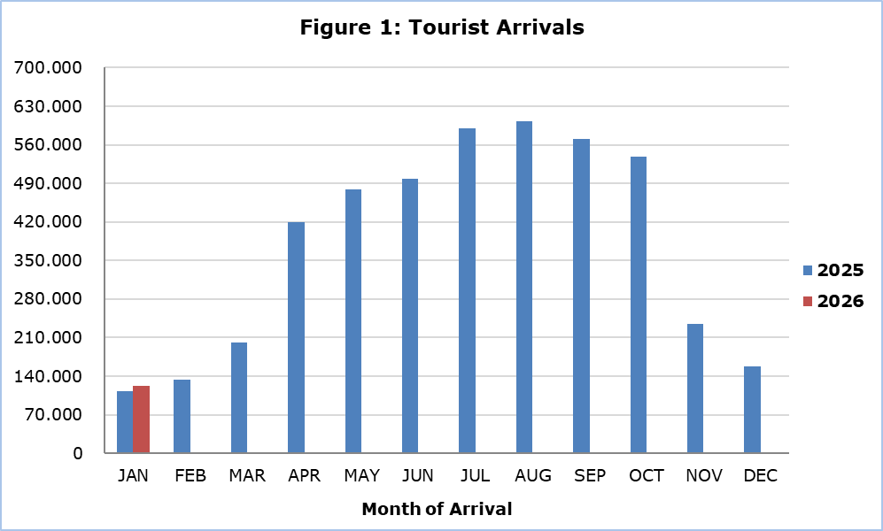

Arrivals from Poland were the main source of tourism for January 2026, with a share of 18,6% (22.575) of total arrivals, followed by Israel with 18,1% (21.981), the United Kingdom with 15,8% (19.180), Greece with 9,6% (11.650) and Germany with 6,2% (7.504) (Table 1).

Table 1
Country of Usual Residence | Tourist Arrivals
Country of Usual Residence | January |  |  | Percentage Change  (%)  Jan. 2026/25
Country of Usual Residence | 2024 | 2025 | 2026 | Percentage Change  (%)  Jan. 2026/25
TOTAL | 87.961 | 112.100 | 121.625 | 8,5
Austria | 832 | 1.126 | 1.549 | 37,6
France | 1.647 | 1.341 | 1.358 | 1,3
Germany | 2.952 | 4.114 | 7.504 | 82,4
Denmark | 420 | u | u | u
Switzerland | 976 | 880 | 1.275 | 44,9
Greece | 10.384 | 11.288 | 11.650 | 3,2
United Kingdom | 16.321 | 18.701 | 19.180 | 2,6
Israel | 9.148 | 23.704 | 21.981 | -7,3
Lebanon | 2.156 | 2.367 | 1.773 | -25,1
Norway | 247 | 432 | u | u
Netherlands | 1.028 | 1.560 | 1.539 | -1,3
Hungary | 1.850 | 1.100 | 1.061 | -3,5
Poland | 15.978 | 15.791 | 22.575 | 43,0
Romania | 1.781 | 2.421 | 2.232 | -7,8
Sweden | 498 | 816 | 1.008 | 23,5
Other | 21.743 | 26.344 | 26.323 | -0,1
u: Data with low reliability.

In January 2026, 60,7% of tourists travelled for holidays, 22,8% visited friends and relatives and 16,2% travelled for business purposes. Respectively, in January 2025, 56,4% of tourists visited Cyprus for holidays, 24,5% visited friends or relatives and 19,0% visited Cyprus for business purposes (Table 2).

Table 2
Purpose of Visit | Percentage (%)
Purpose of Visit | Jan. 2024 | Jan. 2025 | Jan. 2026
Holidays | 60,8 | 56,4 | 60,7
Visiting friends & relatives | 21,2 | 24,5 | 22,8
Business | 17,2 | 19,0 | 16,2

Returns of Residents of Cyprus

A total of 170.045 residents of Cyprus returned from a trip abroad in January 2026 compared to 147.858 in the corresponding month last year, recording an increase of 15,0%.

The main countries from which residents of Cyprus returned in January 2026 were Greece with a share of 27,6% (46.970), the United Kingdom with 8,5% (14.398) and Poland with 5,8% (9.865).

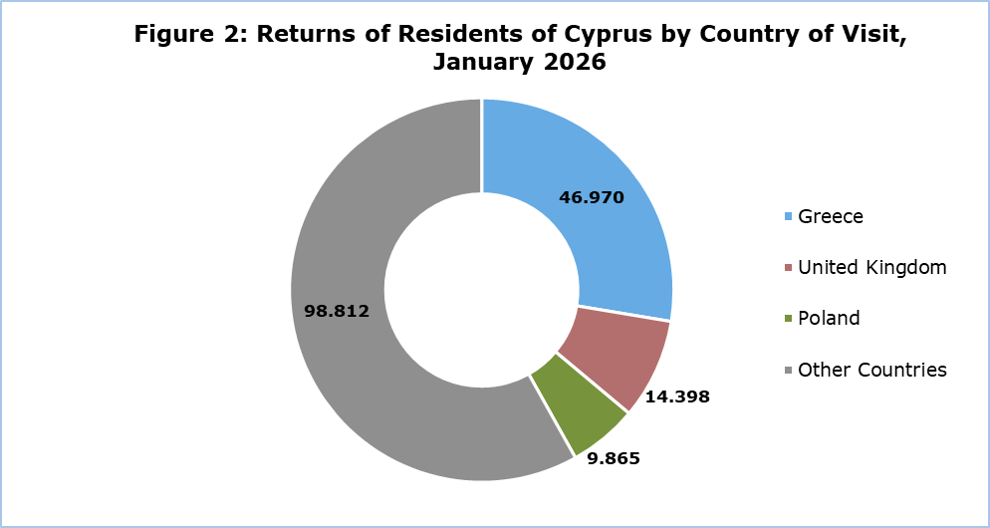

The purpose of travel for the residents of Cyprus in January 2026 was mainly holidays, with a percentage of 82,2%, whilst business reasons held a percentage of 16,3%, studies 0,7% and other reasons 0,7%.

METHODOLOGICAL INFORMATION

Definitions

Tourists – Visitors who stay for at least one night in Cyprus.

Tourist arrivals – The term refers to the number of trips and not to the number of persons. This differs in the sense that one person can take more than one trip during the reference period.

Residents of Cyprus - This category includes persons who have resided in Cyprus for at least 12 months or who have come to Cyprus with the intention of staying for at least 12 months, prior to their travel.

Source of Data and Coverage

The data are obtained from the Passengers Survey which is carried out at the points of arrival in Larnaka and Pafos airports. Additionally, data are also collected from administrative sources, such as the monthly arrivals from ports.

The data covers all persons who pass through passport control at the ports and airports in the Government controlled area of Cyprus. It does not include travelers who arrive and depart illegally via ports and airports in the occupied part of Cyprus.

The weighting was conducted based on the data sent to the Statistical Service by the Civil Aviation Department and from the ship manifests, as well as on the data sent by the Analysis and Statistics Office of the Cyprus Police.

For more information:
CYSTAT Portal, subtheme Tourism
CYSTAT-DB (Online Database)
Predefined Tables (Excel)
Methodological Information

Contact
Lucy Panayidou: Tel.: +357-22602152, E-mail: lpanagidou@cystat.mof.gov.cy

