17 December, 2025

PRESS RELEASE

TOURIST ARRIVALS AND RETURNS OF RESIDENTS OF CYPRUS FROM TRIPS ABROAD: NOVEMBER 2025

Tourist Arrivals 30,4% and Returns of Residents of Cyprus 14,1%

Tourist Arrivals

The arrivals of tourists reached 234.580 in November 2025 compared to 179.941 in November 2024, recording an increase of 30,4%.

For the period of January – November 2025, arrivals of tourists totaled 4.377.114 compared to 3.907.137 in the corresponding period of 2024, recording an increase of 12,0%.

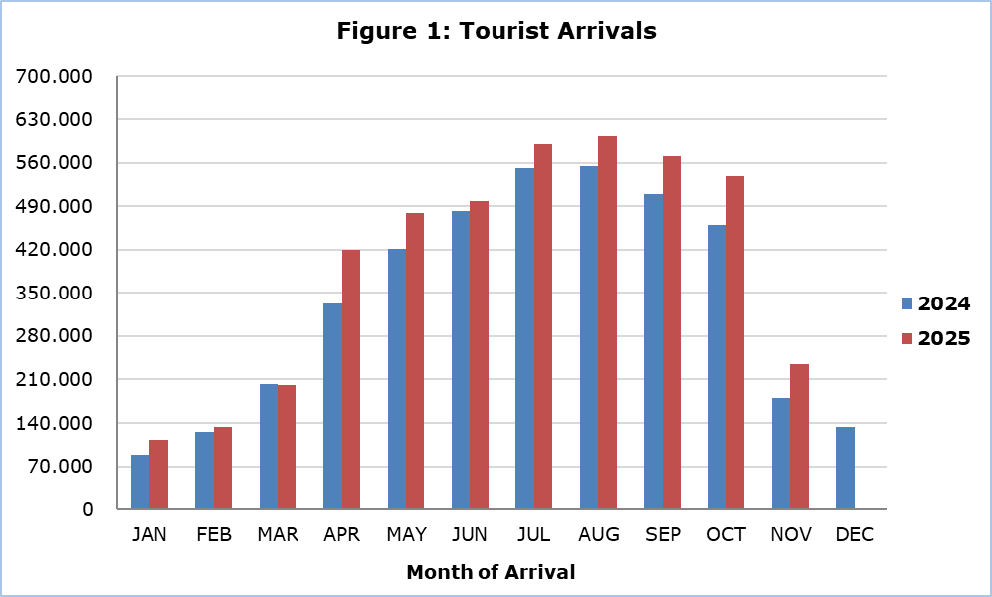

Arrivals from the United Kingdom were the main source of tourism for November 2025, with a share of 22,7% (53.267) of total arrivals, followed by Poland with 13,2% (30.983), Israel with 11,4% (26.816), Germany with 10,4% (24.361) and Greece with 6,0% (13.965) (Table 1).

Table 1
Country of Usual Residence | Tourist Arrivals
Country of Usual Residence | November |  |  | Percentage Change  (%)  Nov. 2025/24
Country of Usual Residence | 2023 | 2024 | 2025 | Percentage Change  (%)  Nov. 2025/24
TOTAL | 159.605 | 179.941 | 234.580 | 30,4
Austria | 3.431 | 3.255 | 6.948 | 113,5
France | 3.575 | 2.269 | 2.718 | 19,8
Germany | 15.984 | 16.424 | 24.361 | 48,3
Denmark | 1.355 | 1.609 | 1.973 | 22,6
Switzerland | 2.288 | 2.659 | 3.166 | 19,1
Greece | 15.475 | 16.015 | 13.965 | -12,8
United Kingdom | 42.724 | 46.598 | 53.267 | 14,3
Israel | 6.228 | 18.840 | 26.816 | 42,3
Lebanon | 2.035 | 1.849 | 2.438 | 31,9
Norway | 1.545 | 2.105 | 2.863 | 36,0
Netherlands | 2.344 | 2.974 | 4.174 | 40,3
Hungary | 2.683 | 1.283 | 2.265 | 76,5
Poland | 18.874 | 20.331 | 30.983 | 52,4
Romania | 2.948 | 2.979 | 5.875 | 97,2
Sweden | 2.131 | 2.604 | 4.474 | 71,8
Other | 35.985 | 38.147 | 48.294 | 26,6

For a percentage of 72,0% of tourists, the purpose of their trip in November 2025 was holidays, for 13,1% visit to friends and relatives and for 14,4% business. Respectively, in November 2024, 64,5% of tourists visited Cyprus for holidays, 17,2% visited friends or relatives and 18,1% visited Cyprus for business reasons (Table 2).

Table 2
Purpose of Visit | Percentage (%)
Purpose of Visit | Nov. 2023 | Nov. 2024 | Nov. 2025
Holidays | 67,2 | 64,5 | 72,0
Visiting friends & relatives | 19,7 | 17,2 | 13,1
Business | 12,8 | 18,1 | 14,4

Returns of Residents of Cyprus

A total number of 137.210 residents of Cyprus returned from a trip abroad in November 2025 compared to 120.248 in the corresponding month last year, recording an increase of 14,1%.

The main countries from which residents of Cyprus returned in November 2025 were Greece with a share of 30,9% (42.442), the United Kingdom with 9,7% (13.286) and Italy with 4,5% (6.114).

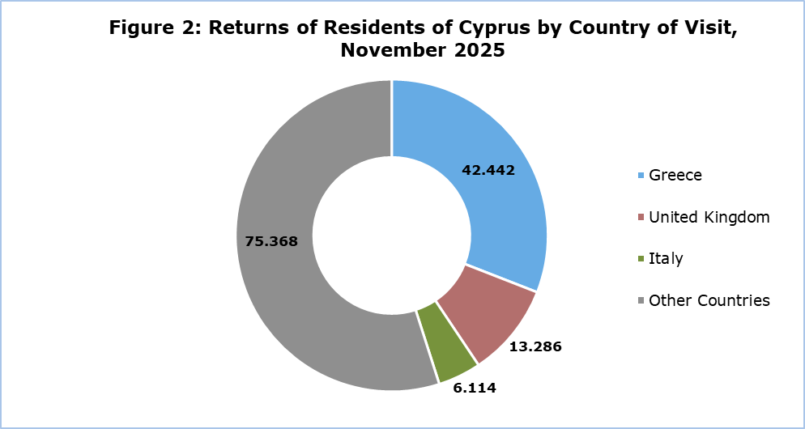

The purpose of travel for the residents of Cyprus in November 2025 was mainly holidays, with a percentage of 65,9%, whilst business reasons held a percentage of 31,5%, studies 1,3% and other reasons 1,3%.

METHODOLOGICAL INFORMATION

Definitions

Tourists – Visitors who stay for at least one night in Cyprus.

Tourist arrivals – The term refers to the number of trips and not to the number of persons. This differs in the sense that one person can take more than one trips during the reference period.

Residents of Cyprus - This category includes persons who have resided in Cyprus for at least 12 months or who have come to Cyprus with the intention of staying for at least 12 months, prior to their travel.

Source of Data and Coverage

The data are obtained from the Passengers Survey which is carried out at the points of arrival in Larnaka and Pafos airports. Additionally, data are also collected from administrative sources, such as the monthly arrivals from ports.

The data covers all persons who pass through passport control at the ports and airports in the Government controlled area of Cyprus. It does not include travelers who arrive and depart illegally via ports and airports in the occupied part of Cyprus.

The weighting was conducted based on the data sent to the Statistical Service by the Civil Aviation Department and from the ship manifests, as well as on the data sent by the Analysis and Statistics Office of the Cyprus Police.

For more information:
CYSTAT Portal, subtheme Tourism
CYSTAT-DB (Online Database)
Predefined Tables (Excel)
Methodological Information

The Predefined Tables available in Excel format, include data up to December 2024. As of January 2025, data will only be available in the Online Database CYSTAT-DB.

Contact
Lucy Panayidou: Tel.: +357-22602152, E-mail: lpanagidou@cystat.mof.gov.cy

