17 November, 2025

PRESS RELEASE

TOURIST ARRIVALS AND RETURNS OF RESIDENTS OF CYPRUS FROM TRIPS ABROAD: OCTOBER 2025

Tourist Arrivals 17,1% and Returns of Residents of Cyprus 15,3%

Tourist Arrivals

The arrivals of tourists reached 537.744 in October 2025 compared to 459.106 in October 2024, recording an increase of 17,1%.

For the period of January – October 2025, arrivals of tourists totaled 4.142.534 compared to 3.727.196 in the corresponding period of 2024, recording an increase of 11,1%.

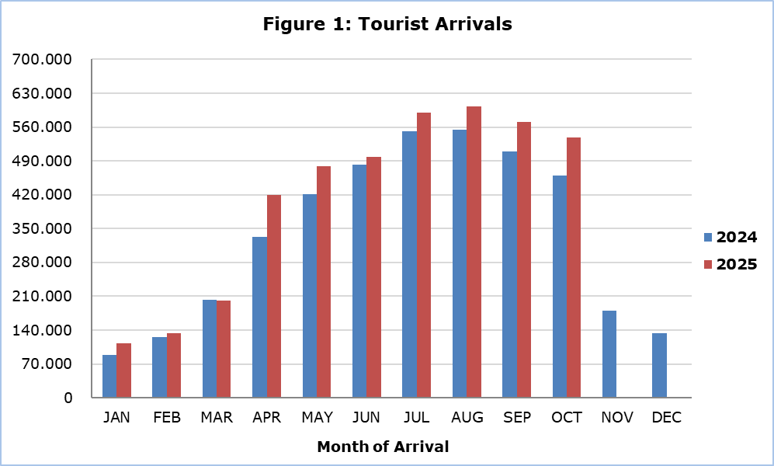

Arrivals from the United Kingdom were the main source of tourism for October 2025, with a share of 31,4% (168.792) of total arrivals, followed by Israel with 11,1% (59.508), Germany with 7,8% (41.783), Poland with 6,7% (36.262), Sweden with 3,9% (20.806) and Greece with 3,7% (20.038) (Table 1).

Table 1
Country of Usual Residence | Tourist Arrivals
Country of Usual Residence | October |  |  | Percentage Change  (%)  Oct. 2025/24
Country of Usual Residence | 2023 | 2024 | 2025 | Percentage Change  (%)  Oct. 2025/24
TOTAL | 426.272 | 459.106 | 537.744 | 17,1
Austria | 13.924 | 11.010 | 14.895 | 35,3
France | 8.535 | 8.632 | 10.824 | 25,4
Germany | 30.178 | 34.822 | 41.783 | 20,0
Denmark | 11.041 | 9.537 | 9.378 | -1,7
Switzerland | 12.114 | 12.274 | 12.416 | 1,2
Greece | 18.242 | 17.689 | 20.038 | 13,3
United Kingdom | 154.373 | 166.588 | 168.792 | 1,3
Israel | 24.428 | 24.088 | 59.508 | 147,0
Lebanon | 3.454 | 3.923 | 2.593 | -33,9
Norway | 7.592 | 7.867 | 6.598 | -16,1
Netherlands | 6.584 | 9.867 | 9.420 | -4,5
Hungary | 6.930 | 6.583 | 9.559 | 45,2
Poland | 28.649 | 37.010 | 36.262 | -2,0
Romania | 8.736 | 13.053 | 14.744 | 13,0
Sweden | 16.288 | 18.713 | 20.806 | 11,2
Other | 75.204 | 77.450 | 100.128 | 29,3

For a percentage of 81,8% of tourists, the purpose of their trip in October 2025 was holidays, for 11,0% visit to friends and relatives and for 7,1% business. Respectively, in October 2024, 79,9% of tourists visited Cyprus for holidays, 11,9% visited friends or relatives and 8,1% visited Cyprus for business reasons (Table 2).

Table 2
Purpose of Visit | Percentage (%)
Purpose of Visit | Oct. 2023 | Oct. 2024 | Oct. 2025
Holidays | 82,5 | 79,9 | 81,8
Visiting friends & relatives | 10,9 | 11,9 | 11,0
Business | 6,4 | 8,1 | 7,1

Returns of Residents of Cyprus

A total number of 158.026 residents of Cyprus returned from a trip abroad in October 2025 compared to 137.095 in the corresponding month last year, recording an increase of 15,3%.

The main countries from which residents of Cyprus returned in October 2025 were Greece with a share of 33,1% (52.381), the United Kingdom with 7,3% (11.585), Italy with 5,7% (9.034) and Germany with 4,4% (6.914).

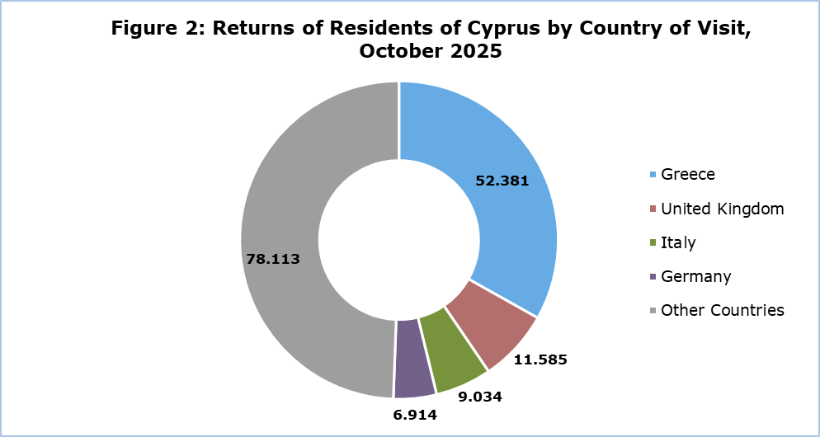

The purpose of travel for the residents of Cyprus in October 2025 was mainly holidays, with a percentage of 69,2%, whilst business reasons held a percentage of 27,1%, studies 1,5% and other reasons 2,3%.

METHODOLOGICAL INFORMATION

Definitions

Tourists – Visitors who stay for at least one night in Cyprus.

Tourist arrivals – The term refers to the number of trips and not to the number of persons. This differs in the sense that one person can take more than one trips during the reference period.

Residents of Cyprus - This category includes persons who have resided in Cyprus for at least 12 months or who have come to Cyprus with the intention of staying for at least 12 months, prior to their travel.

Source of Data and Coverage

The data are obtained from the Passengers Survey which is carried out at the points of arrival in Larnaka and Pafos airports. Additionally, data are also collected from administrative sources, such as the monthly arrivals from ports.

The data covers all persons who pass through passport control at the ports and airports in the Government controlled area of Cyprus. It does not include travelers who arrive and depart illegally via ports and airports in the occupied part of Cyprus.

The weighting was conducted based on the data sent to the Statistical Service by the Civil Aviation Department and from the ship manifests, as well as on the data sent by the Analysis and Statistics Office of the Cyprus Police.

For more information:
CYSTAT Portal, subtheme Tourism
CYSTAT-DB (Online Database)
Predefined Tables (Excel)
Methodological Information

The Predefined Tables available in Excel format, include data up to December 2024. As of January 2025, data will only be available in the Online Database CYSTAT-DB.

Contact
Lucy Panayidou: Tel.: +35722602152, E-mail: lpanagidou@cystat.mof.gov.cy

