17 October, 2025

**PRESS RELEASE**

###### TOURIST ARRIVALS AND RETURNS OF RESIDENTS OF CYPRUS FROM TRIPS ABROAD: SEPTEMBER 2025

**Tourist Arrivals 12,0% and Returns of Residents of Cyprus 6,4%**

**Tourist Arrivals**

The arrivals of tourists reached 570.635 in September 2025 compared to 509.463 in September 2024, recording an increase of 12,0%.

For the period of January – September 2025, arrivals of tourists totaled 3.604.790 compared to 3.268.090 in the corresponding period of 2024, recording an increase of 10,3%.

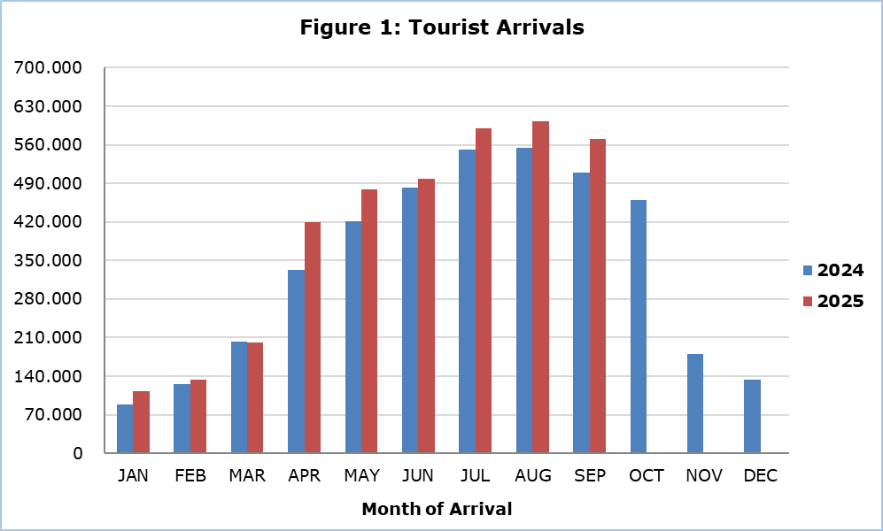

Arrivals from the United Kingdom were the main source of tourism for September 2025, with a share of 31,4% (179.293) of total arrivals, followed by Israel with 14,0% (80.115), Poland with 7,9% (45.019), Germany with 6,0% (34.348), Sweden with 3,6% (20.570), Romania with 3,1% (17.975) and Greece with 3,0% (17.217) (Table 1).

|  |  |  |  |  |
| --- | --- | --- | --- | --- |
| **Table 1** |  | | | |
| **Country of Usual Residence** | **Tourist Arrivals** | | | |
| **September** | | | **Percentage Change**  **(%)**  **Sep. 2025/24** |
| **2023** | **2024** | **2025** |
| **TOTAL** | **487.350** | **509.463** | **570.635** | **12,0** |
| Austria | 9.335 | 9.758 | 12.333 | 26,4 |
| France | 8.578 | 9.870 | 9.771 | -1,0 |
| Germany | 26.907 | 24.594 | 34.348 | 39,7 |
| Denmark | 8.895 | 9.015 | 9.113 | 1,1 |
| Switzerland | 11.163 | 11.366 | 10.663 | -6,2 |
| Greece | 15.520 | 15.479 | 17.217 | 11,2 |
| United Kingdom | 165.869 | 180.961 | 179.293 | -0,9 |
| Israel | 57.088 | 54.557 | 80.115 | 46,8 |
| Lebanon | 4.017 | 4.512 | 3.827 | -15,2 |
| Norway | 9.008 | 10.439 | 9.495 | -9,0 |
| Netherlands | 5.777 | 7.509 | 7.821 | 4,2 |
| Hungary | 9.630 | 8.998 | 9.264 | 3,0 |
| Poland | 32.530 | 42.295 | 45.019 | 6,4 |
| Romania | 10.072 | 14.705 | 17.975 | 22,2 |
| Sweden | 22.196 | 21.609 | 20.570 | -4,8 |
| Other | 90.765 | 83.796 | 103.811 | 23,9 |

For a percentage of 84,8% of tourists, the purpose of their trip in September 2025 was holidays, for 10,1% visit to friends and relatives and for 5,0% business. Respectively, in September 2024, 85,1% of tourists visited Cyprus for holidays, 9,6% visited friends or relatives and 5,2% visited Cyprus for business reasons (Table 2).

|  |  |  |  |
| --- | --- | --- | --- |
| **Table 2** |  |  |  |
| **Purpose of Visit** | **Percentage (%)** | | |
| **Sep. 2023** | **Sep. 2024** | **Sep. 2025** |
| Holidays | 84,1 | 85,1 | 84,8 |
| Visiting friends & relatives | 10,3 | 9,6 | 10,1 |
| Business | 5,5 | 5,2 | 5,0 |

**Returns of Residents of Cyprus**

A total number of 166.129 residents of Cyprus returned from a trip abroad in September 2025 compared to 156.153 in the corresponding month last year, recording an increase of 6,4%.

The main countries from which residents of Cyprus returned in September 2025 were Greece with a share of 35,8% (59.514), Russia with 6,6% (10.987), the United Kingdom with 6,6% (10.964) and Italy with 5,2% (8.711).

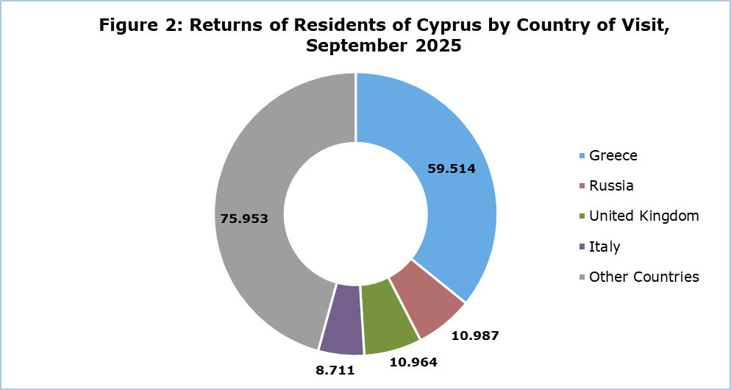

The purpose of travel for the residents of Cyprus in September 2025 was mainly holidays, with a percentage of 76,1%, whilst business reasons held a percentage of 21,0%, studies 1,6% and other reasons 1,3%.

**METHODOLOGICAL INFORMATION**

**Definitions**

**Tourists** – Visitors who stay for at least one night in Cyprus.

**Tourist arrivals** – The term refers to the number of trips and not to the number of persons. This differs in the sense that one person can take more than one trips during the reference period.

**Residents of Cyprus -** This category includes persons who have resided in Cyprus for at least 12 months or who have come to Cyprus with the intention of staying for at least 12 months, prior to their travel.

**Source of Data and Coverage**

The data are obtained from the Passengers Survey which is carried out at the points of arrival in Larnaka and Pafos airports. Additionally, data are also collected from administrative sources, such as the monthly arrivals from ports.

The data covers all persons who pass through passport control at the ports and airports in the Government controlled area of Cyprus. It does not include travelers who arrive and depart illegally via ports and airports in the occupied part of Cyprus.

The weighting was conducted based on the data sent to the Statistical Service by the Civil Aviation Department and from the ship manifests, as well as on the data sent by the Analysis and Statistics Office of the Cyprus Police.

***For more information:***

CYSTAT Portal, subtheme [Tourism](https://www.cystat.gov.cy/en/SubthemeStatistics?s=51)

[CYSTAT-DB](https://cystatdb23px.cystat.gov.cy/pxweb/en/8.CYSTAT-DB/8.CYSTAT-DB__Tourism__) (Online Database)

[Predefined Tables](https://www.cystat.gov.cy/en/KeyFiguresList?s=51) (Excel)

[Methodological Information](https://www.cystat.gov.cy/en/MethodologicalDetails?m=2172)

**The Predefined Tables available in Excel format, include data up to December 2024. As of January 2025, data will only be available in the Online Database CYSTAT-DB.**

*Contact*

Lucy Panayidou: Tel.: +35722602152, E-mail: [lpanagidou@cystat.mof.gov.cy](mailto:lpanagidou@cystat.mof.gov.cy)