17 January, 2024

**PRESS RELEASE**

###### TOURIST ARRIVALS AND RETURNS OF RESIDENTS OF CYPRUS FROM TRIPS ABROAD: DECEMBER 2023

**Tourist Arrivals +12,3% and Returns of Residents of Cyprus +9,8%**

**Tourist Arrivals**

The arrivals of tourists reached 123.630 in December 2023 compared to 110.041 in December 2022, recording an increase of 12,3%.

For the period of January – December 2023, arrivals of tourists totaled 3.845.652 compared to 3.201.080 in the corresponding period of 2022, recording an increase of 20,1%.

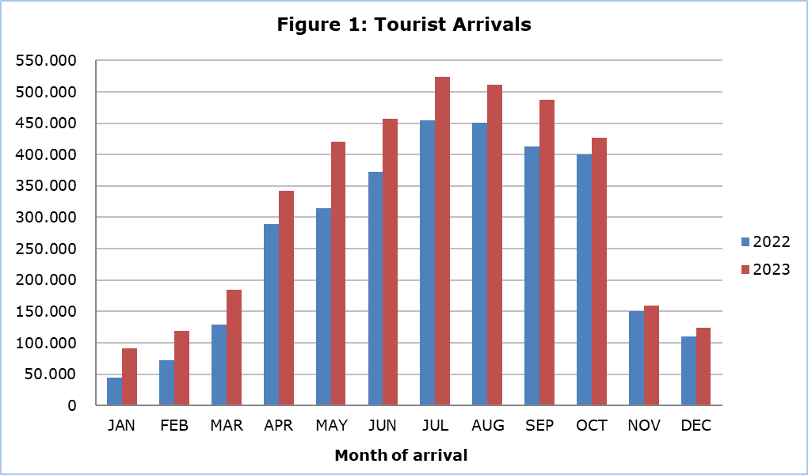

Arrivals from the United Kingdom were the main source of tourism for December 2023, with a share of 23,4% (28.973) of total arrivals, followed by Poland with 11,5% (14.233) and Greece with 10,3% (12.792).

For a percentage of 58,4% of tourists, the purpose of their trip in December 2023 was holidays, for 30,4% visit to friends and relatives and for 11,0% business. Respectively, in December 2022, 61,9% of tourists visited Cyprus for holidays, 27,4% visited friends or relatives and 10,4% visited Cyprus for business reasons (Table).

|  |  |  |  |
| --- | --- | --- | --- |
| **Table** |  |  |  |
| **Purpose of Visit** | **Percentage (%)** | | |
| **Dec. 2021** | **Dec. 2022** | **Dec. 2023** |
| Holidays | 61,5 | 61,9 | 58,4 |
| Visiting friends & relatives | 29,0 | 27,4 | 30,4 |
| Business | 9,5 | 10,4 | 11,0 |

**Returns of Residents of Cyprus**

A total number of 153.736 residents of Cyprus returned from a trip abroad in December 2023 compared to 139.981 in the corresponding month last year, recording an increase of 9,8%.

The main countries from which residents of Cyprus returned in December 2023 were Greece with a share of 30,2% (46.376), the United Kingdom with 15,3% (23.478) and Poland with 4,6% (7.006).

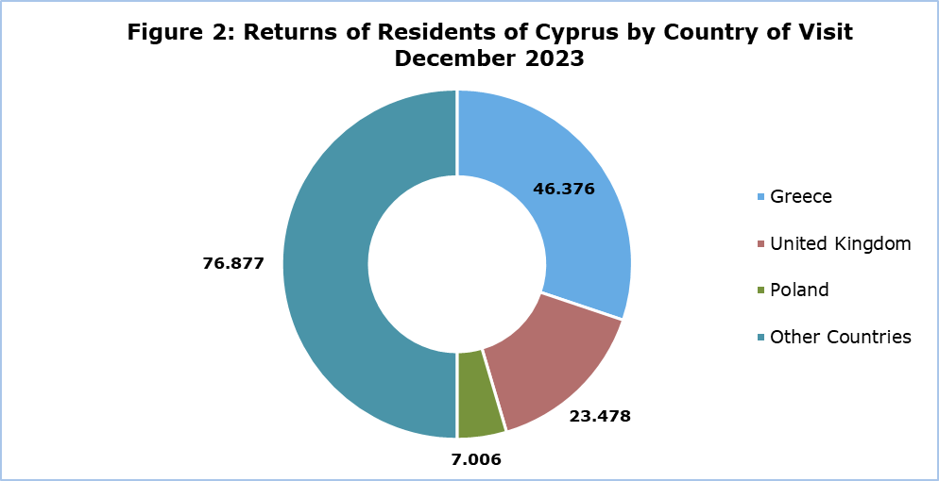

The purpose of travel for the residents of Cyprus in December 2023 was mainly holidays, with a percentage of 62,5%, whilst business reasons held a percentage of 16,3%, studies 20,5% and other reasons 0,8%.

**METHODOLOGICAL NOTES**

**Definitions**

**Tourists** – Visitors who stay for at least one night in Cyprus.

**Tourist arrivals** – The term refers to the number of trips and not to the number of persons. This differs in the sense that one person can take more than one trips during the reference period.

**Residents of Cyprus -** This category includes persons who have resided in Cyprus for at least 12 months or who have come to Cyprus with the intention of staying for at least 12 months, prior to their travel.

**Source of Data and Coverage**

The data are obtained from the Passengers Survey which is carried out at the points of arrival in Larnaka and Pafos airports. Additionally, data are also collected from administrative sources, such as the monthly arrivals from ports.

The data covers all persons who pass through passport control at the ports and airports in the Government controlled area of Cyprus. It does not include travelers who arrive and depart illegally via ports and airports in the occupied part of Cyprus.

The weighting was conducted based on the data sent to the Statistical Service by the Civil Aviation Department and from the ship manifests, as well as on the data sent by the Analysis and Statistics Office of the Cyprus Police.

***For more information:***

CYSTAT Portal, subtheme [Tourism](https://www.cystat.gov.cy/en/SubthemeStatistics?s=51)

[CYSTAT-DB](https://cystatdb.cystat.gov.cy/pxweb/en/8.CYSTAT-DB/8.CYSTAT-DB__Tourism__) (Online Database)

[Predefined Tables](https://www.cystat.gov.cy/en/KeyFiguresList?s=51) (Excel)

[Methodological Information](https://www.cystat.gov.cy/en/MethodologicalDetails?m=2172)

*Contact*

Lucy Panayidou: Tel.:+35722602152, E-mail: [lpanagidou@cystat.mof.gov.cy](mailto:lpanagidou@cystat.mof.gov.cy)