17 February, 2025

**PRESS RELEASE**

###### TOURIST ARRIVALS AND RETURNS OF RESIDENTS OF CYPRUS FROM TRIPS ABROAD: JANUARY 2025

**Tourist Arrivals 27,4% and Returns of Residents of Cyprus -3,7%**

**Tourist Arrivals**

The arrivals of tourists reached 112.100 in January 2025 compared to 87.961 in January 2024, recording an increase of 27,4%.

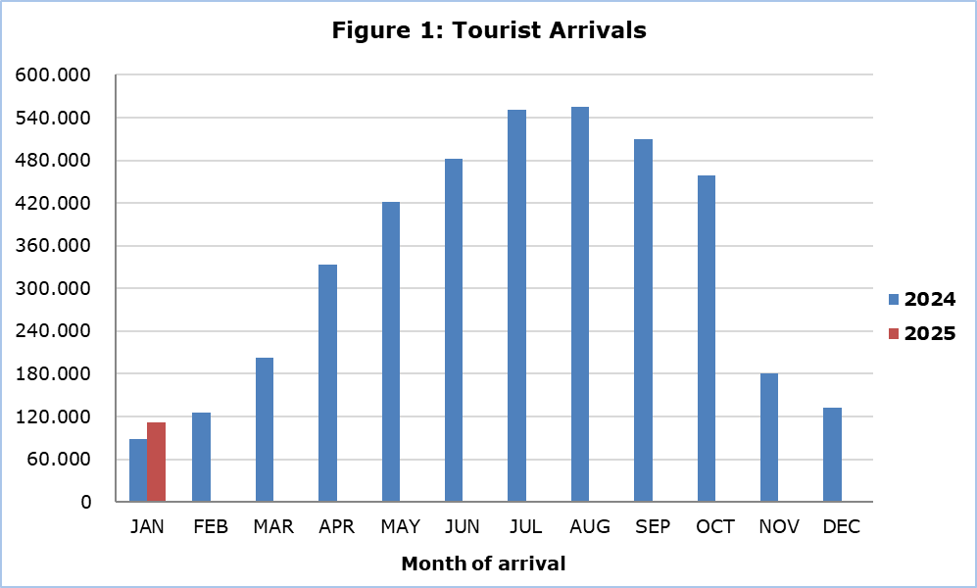

Arrivals from Israel were the main source of tourism for January 2025, with a share of 21,1% (23.704) of total arrivals, followed by the United Kingdom with 16,7% (18.701), Poland with 14,1% (15.791) and Greece with 10,1% (11.288) (Table 1).

|  |  |  |  |  |
| --- | --- | --- | --- | --- |
| **Table 1** |  | | | |
| **Country of Usual Residence** | **Tourist Arrivals** | | | |
| **January** | | | **Percentage Change**  **(%)**  **Jan. 2025/24** |
| **2023** | **2024** | **2025** |
| **TOTAL** | **90.549** | **87.961** | **112.100** | **27,4** |
| Austria | 624 | 832 | 1.126 | 35,3 |
| France | 1.537 | 1.647 | 1.341 | -18,6 |
| Germany | 3.897 | 2.952 | 4.114 | 39,4 |
| Denmark | 607 | 420 | u | ... |
| Switzerland | 548 | 976 | 880 | -9,8 |
| Greece | 10.459 | 10.384 | 11.288 | 8,7 |
| United Kingdom | 18.631 | 16.321 | 18.701 | 14,6 |
| Israel | 14.991 | 9.148 | 23.704 | 159,1 |
| Lebanon | 1.868 | 2.156 | 2.367 | 9,8 |
| Norway | u | 247 | 432 | 74,9 |
| Netherlands | 1.131 | 1.028 | 1.560 | 51,8 |
| Hungary | 957 | 1.850 | 1.100 | -40,5 |
| Poland | 11.166 | 15.978 | 15.791 | -1,2 |
| Romania | 2.782 | 1.781 | 2.421 | 35,9 |
| Sweden | 1.090 | 498 | 816 | 63,9 |
| Other | 20.251 | 21.743 | 26.344 | 21,2 |

For a percentage of 56,4% of tourists, the purpose of their trip in January 2025 was holidays, for 24,5% visit to friends and relatives and for 19,0% business. Respectively, in January 2024, 60,8% of tourists visited Cyprus for holidays, 21,2% visited friends or relatives and 17,2% visited Cyprus for business reasons (Table 2).

|  |  |  |  |
| --- | --- | --- | --- |
| **Table 2** |  |  |  |
| **Purpose of Visit** | **Percentage (%)** | | |
| **Jan. 2023** | **Jan. 2024** | **Jan. 2025** |
| Holidays | 64,8 | 60,8 | 56,4 |
| Visiting friends & relatives | 21,4 | 21,2 | 24,5 |
| Business | 13,4 | 17,2 | 19,0 |

**Returns of Residents of Cyprus**

A total number of 147.858 residents of Cyprus returned from a trip abroad in January 2025 compared to 153.499 in the corresponding month last year, recording a decrease of 3,7%.

The main countries from which residents of Cyprus returned in January 2025 were Greece with a share of 29,9% (44.275), the United Kingdom with 11,2% (16.557), Russia with 4,5% (6.621), Italy with 4,4% (6.479) and Germany with 4,3% (6.332).

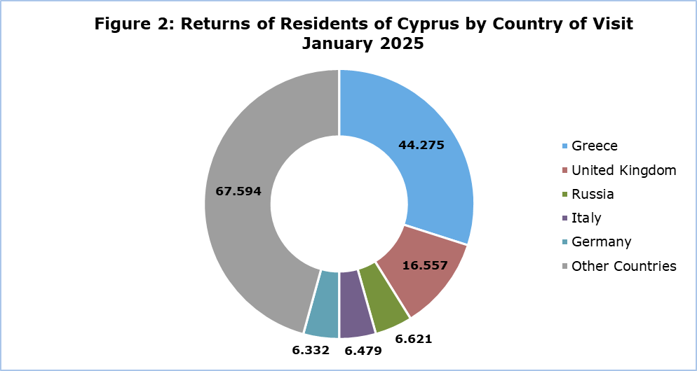

The purpose of travel for the residents of Cyprus in January 2025 was mainly holidays, with a percentage of 78,1%, whilst business reasons held a percentage of 19,9%, studies 1,1% and other reasons 0,8%.

**METHODOLOGICAL INFORMATION**

**Definitions**

**Tourists** – Visitors who stay for at least one night in Cyprus.

**Tourist arrivals** – The term refers to the number of trips and not to the number of persons. This differs in the sense that one person can take more than one trips during the reference period.

**Residents of Cyprus -** This category includes persons who have resided in Cyprus for at least 12 months or who have come to Cyprus with the intention of staying for at least 12 months, prior to their travel.

**Source of Data and Coverage**

The data are obtained from the Passengers Survey which is carried out at the points of arrival in Larnaka and Pafos airports. Additionally, data are also collected from administrative sources, such as the monthly arrivals from ports.

The data covers all persons who pass through passport control at the ports and airports in the Government controlled area of Cyprus. It does not include travelers who arrive and depart illegally via ports and airports in the occupied part of Cyprus.

The weighting was conducted based on the data sent to the Statistical Service by the Civil Aviation Department and from the ship manifests, as well as on the data sent by the Analysis and Statistics Office of the Cyprus Police.

***For more information:***

CYSTAT Portal, subtheme [Tourism](https://www.cystat.gov.cy/en/SubthemeStatistics?s=51)

[CYSTAT-DB](https://cystatdb.cystat.gov.cy/pxweb/en/8.CYSTAT-DB/8.CYSTAT-DB__Tourism__) (Online Database)

[Predefined Tables](https://www.cystat.gov.cy/en/KeyFiguresList?s=51) (Excel)

[Methodological Information](https://www.cystat.gov.cy/en/MethodologicalDetails?m=2172)

**The Predefined Tables available in Excel format, will include data up to December 2024. As of January 2025, data will only be available in the Online Database CYSTAT-DB.**

*Contact*

Lucy Panayidou: Tel.: +35722602152, E-mail: [lpanagidou@cystat.mof.gov.cy](mailto:lpanagidou@cystat.mof.gov.cy)