17 July, 2023

**PRESS RELEASE**

###### TOURIST ARRIVALS AND RETURNS OF RESIDENTS OF CYPRUS FROM TRIPS ABROAD: JUNE 2023

**Tourist Arrivals +22,7% and Returns of Residents of Cyprus +14,4%**

**Tourist Arrivals**

The arrivals of tourists reached 456.985 in June 2023 compared to 372.324 in June 2022, recording an increase of 22,7%.

For the period of January – June 2023, arrivals of tourists totaled 1.613.690 compared to 1.221.382 in the corresponding period of 2022, recording an increase of 32,1%.

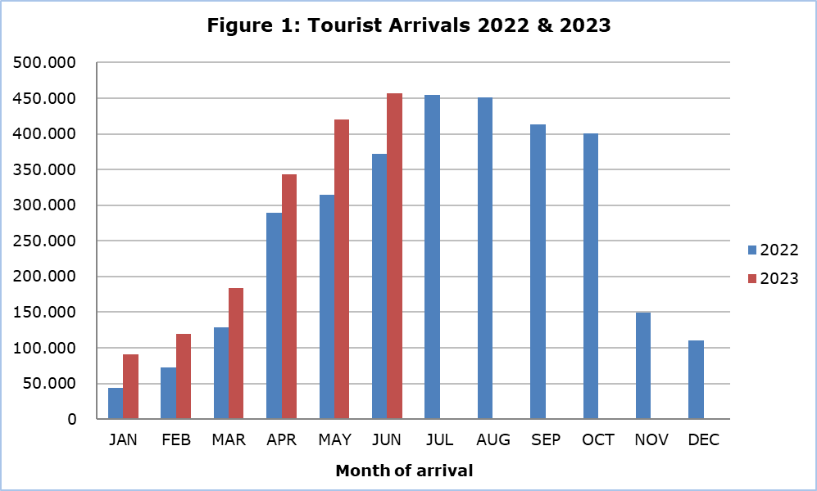

Arrivals from the United Kingdom were the main source of tourism for June 2023, with a share of 34,8% (159.061) of total arrivals, followed by Israel with 10,2% (46.402), Poland with 6,6% (30.293), Sweden with 5,0% (22.724) and Greece with 4,5% (20.722).

For a percentage of 81,7% of tourists, the purpose of their trip in June 2023 was holidays, for 12,6% visit to friends and relatives and for 5,5% business. Respectively, in June 2022, 82,0% of tourists visited Cyprus for holidays, 10,9% visited friends or relatives and 7,0% visited Cyprus for business reasons (Table 1).

|  |  |  |  |  |  |  |  |
| --- | --- | --- | --- | --- | --- | --- | --- |
| **Table 1** | | | | | | | |
| **Purpose of visit** | | **Percentage (%)** | | | | | |
| **June 21** | | **June 22** | | **June 23** | |
| Holidays | | 82,8 | | 82,0 | | 81,7 | |
| Visiting friends & relatives | | 10,9 | | 10,9 | | 12,6 | |
| Business | | 6,3 | | 7,0 | | 5,5 | |

**Returns of Residents of Cyprus**

A total number of 138.588 residents of Cyprus returned from a trip abroad in June 2023 compared to 121.146 in the corresponding month last year, recording an increase of 14,4%.

The main countries from which residents of Cyprus returned in June 2023 were Greece with a share of 30,8% (42.662), the United Kingdom with 11,2% (15.493), Italy with 7,1% (9.776) and France with 4,2% (5.776).

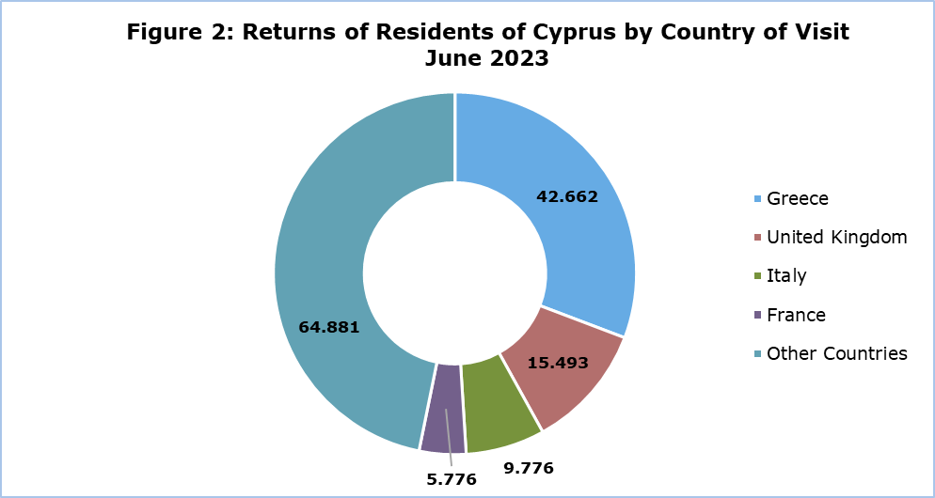

The purpose of travel for the residents of Cyprus in June 2023 was mainly holidays, with a percentage of 61,9%, whilst business reasons held a percentage of 26,0%, studies 9,8% and other reasons 2,3%.

**METHODOLOGICAL NOTES**

**Definitions**

**Tourists** – Visitors who stay for at least one night in Cyprus.

**Tourist arrivals** – The term refers to the number of trips and not to the number of persons. This differs in the sense that one person can take more than one trips during the reference period.

**Residents of Cyprus -** This category includes persons who have resided in Cyprus for at least 12 months or who have come to Cyprus with the intention of staying for at least 12 months, prior to their travel.

**Source of Data and Coverage**

The data are obtained from the Passengers Survey which is carried out at the points of arrival in Larnaka and Pafos airports. Additionally, data are also collected from administrative sources, such as the monthly arrivals from ports.

The data covers all persons who pass through passport control at the ports and airports in the Government controlled area of Cyprus. It does not include travelers who arrive and depart illegally via ports and airports in the occupied part of Cyprus.

The weighting was conducted based on the data sent to the Statistical Service by the Civil Aviation Department and from the ship manifests, as well as on the data sent by the Analysis and Statistics Office of the Cyprus Police.

***For more information:***

CYSTAT Portal, subtheme [Tourism](https://www.cystat.gov.cy/en/SubthemeStatistics?s=51)

[CYSTAT-DB](https://cystatdb.cystat.gov.cy/pxweb/en/8.CYSTAT-DB/8.CYSTAT-DB__Tourism__) (Online Database)

[Predefined Tables](https://www.cystat.gov.cy/en/KeyFiguresList?s=51) (Excel)

[Methodological Information](https://www.cystat.gov.cy/en/MethodologicalDetails?m=2172)

*Contact*

Lucy Panayidou: Tel.:+35722602152, E-mail: [lpanagidou@cystat.mof.gov.cy](mailto:lpanagidou@cystat.mof.gov.cy)