18 April, 2023

**PRESS RELEASE**

###### TOURIST ARRIVALS AND RETURNS OF RESIDENTS OF CYPRUS FROM TRIPS ABROAD: MARCH 2023

**Tourist Arrivals +43,0% and Returns of Residents of Cyprus +89,9%**

**Tourist Arrivals**

The arrivals of tourists reached 184.263 in March 2023 compared to 128.840 in March 2022, recording an increase of 43,0%.

For the period of January – March 2023, arrivals of tourists totaled 393.893 compared to 244.705 in the corresponding period of 2022, recording an increase of 61,0%.

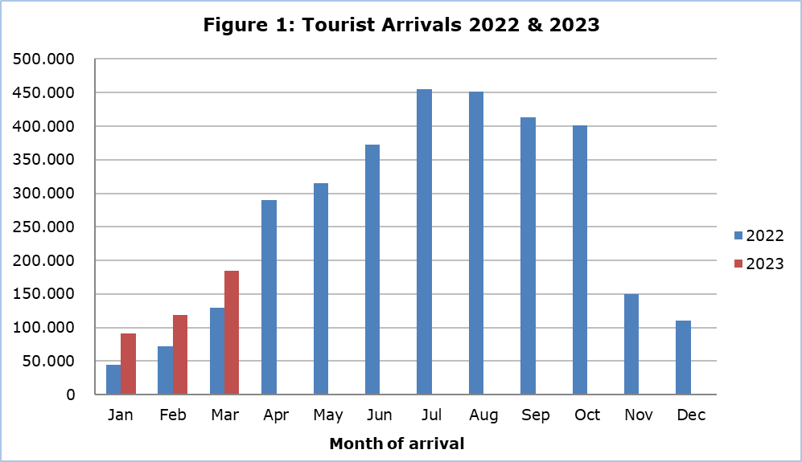

Arrivals from the United Kingdom were the main source of tourism for March 2023, with a share of 33,8% (62.282) of total arrivals, followed by Israel with 12,4% (22.813), Greece with 8,2% (15.122), Poland with 7,6% (14.049) and Germany with 7,0% (12.864).

For a percentage of 71,6% of tourists, the purpose of their trip in March 2023 was holidays, for 14,9% visit to friends and relatives and for 13,3% business. Respectively, in March 2022, 71,9% of tourists visited Cyprus for holidays, 16,3% visited friends or relatives and 11,8% visited Cyprus for business reasons (Table 1).

|  |  |  |  |  |
| --- | --- | --- | --- | --- |
| **Table 1** | | | | |
| **Purpose of visit** | | **Percentage (%)** | | |
| **Mar 21** | **Mar 22** | **Mar 23** |
| Holidays | 25,2 | | 71,9 | 71,6 |
| Visiting friends & relatives | 35,2 | | 16,3 | 14,9 |
| Business | 39,4 | | 11,8 | 13,3 |

**Returns of Residents of Cyprus**

A total number of 113.805 residents of Cyprus returned from a trip abroad in March 2023 compared to 59.918 in the corresponding month last year, recording an increase of 89,9%.

The main countries from which residents of Cyprus returned in March 2023 were Greece with a share of 30,3% (34.455), the United Kingdom with 14,4% (16.386), Bulgaria with 4,0% (4.527) and Italy with 3,5% (3.959).

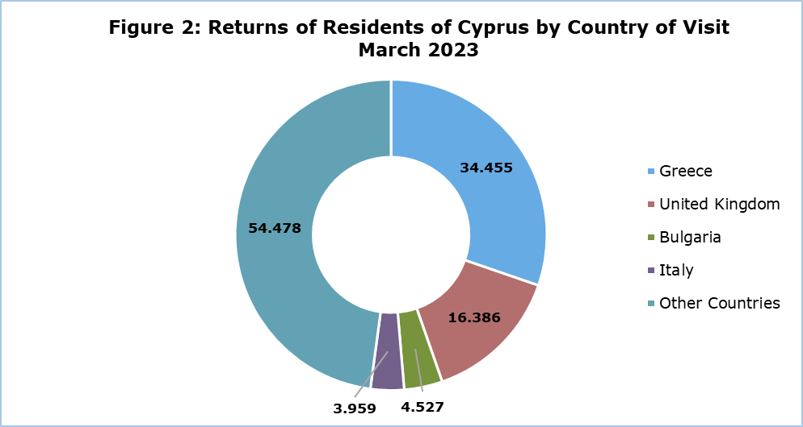

The purpose of travel for the residents of Cyprus in March 2023 was mainly holidays, with a percentage of 68,2%, whilst business reasons held a percentage of 26,1%, studies 4,0% and other reasons 1,8%.

**METHODOLOGICAL NOTES**

**Definitions**

**Tourists** – Visitors who stay for at least one night in Cyprus.

**Tourist arrivals** – The term refers to the number of trips and not to the number of persons. This differs in the sense that one person can take more than one trips during the reference period.

**Residents of Cyprus -** This category includes persons who have resided in Cyprus for at least 12 months or who have come to Cyprus with the intention of staying for at least 12 months, prior to their travel.

**Source of Data and Coverage**

The data are obtained from the Passengers Survey which is carried out at the points of arrival in Larnaca and Paphos airports. Additionally, data are also collected from administrative sources, such as the monthly arrivals from ports.

The data covers all persons who pass through passport control at the ports and airports in the Government controlled area of Cyprus. It does not include travelers who arrive and depart illegally via ports and airports in the occupied part of Cyprus.

The weighting was conducted based on the data sent to the Statistical Service by the Civil Aviation Department and from the ship manifests, as well as on the data sent by the Analysis and Statistics Office of the Cyprus Police.

***For more information:***

CYSTAT Portal, subtheme [Tourism](https://www.cystat.gov.cy/en/SubthemeStatistics?s=51)

[CYSTAT-DB](https://cystatdb.cystat.gov.cy/pxweb/en/8.CYSTAT-DB/8.CYSTAT-DB__Tourism__) (Online Database)

[Predefined Tables](https://www.cystat.gov.cy/en/KeyFiguresList?s=51) (Excel)

[Methodological Information](https://www.cystat.gov.cy/en/MethodologicalDetails?m=2172)

*Contact*

Lucy Panayidou: Tel.:+35722602152, E-mail: [lpanagidou@cystat.mof.gov.cy](mailto:lpanagidou@cystat.mof.gov.cy)