17 April, 2024

**PRESS RELEASE**

###### TOURIST ARRIVALS AND RETURNS OF RESIDENTS OF CYPRUS FROM TRIPS ABROAD: MARCH 2024

**Tourist Arrivals +9,8% and Returns of Residents of Cyprus +** **12,5%**

**Tourist Arrivals**

The arrivals of tourists reached 202.256 in March 2024 compared to 184.263 in March 2023, recording an increase of 9,8%.

For the period of January – March 2024, arrivals of tourists totaled 415.251 compared to 393.893 in the corresponding period of 2023, recording an increase of 5,4%.

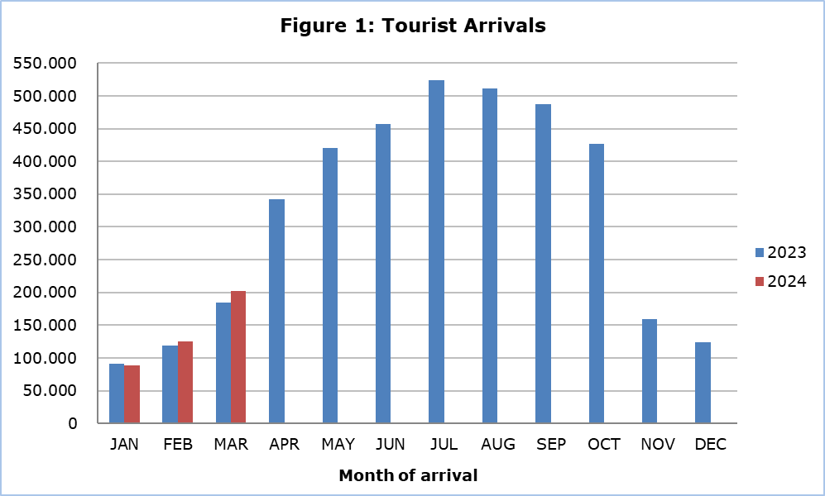

Arrivals from the United Kingdom were the main source of tourism for March 2024, with a share of 31,8% (64.414) of total arrivals, followed by Poland with 10,4% (21.054), Germany with 9,8% (19.732), Greece with 9,1% (18.361) and Israel with 8,2% (16.620).

For a percentage of 76,0% of tourists, the purpose of their trip in March 2024 was holidays, for 13,1% visit to friends and relatives and for 10,7% business. Respectively, in March 2023, 71,6% of tourists visited Cyprus for holidays, 14,9% visited friends or relatives and 13,3% visited Cyprus for business reasons (Table).

|  |  |  |  |
| --- | --- | --- | --- |
| **Table** |  |  |  |
| **Purpose of Visit** | **Percentage (%)** | | |
| **Mar. 2022** | **Mar. 2023** | **Mar. 2024** |
| Holidays | 71,9 | 71,6 | 76,0 |
| Visiting friends & relatives | 16,3 | 14,9 | 13,1 |
| Business | 11,8 | 13,3 | 10,7 |

**Returns of Residents of Cyprus**

A total number of 128.085 residents of Cyprus returned from a trip abroad in March 2024 compared to 113.805 in the corresponding month last year, recording an increase of 12,5%.

The main countries from which residents of Cyprus returned in March 2024 were Greece with a share of 32,8% (42.046), the United Kingdom with 12,8% (16.366) and Italy with 5,4% (6.916).

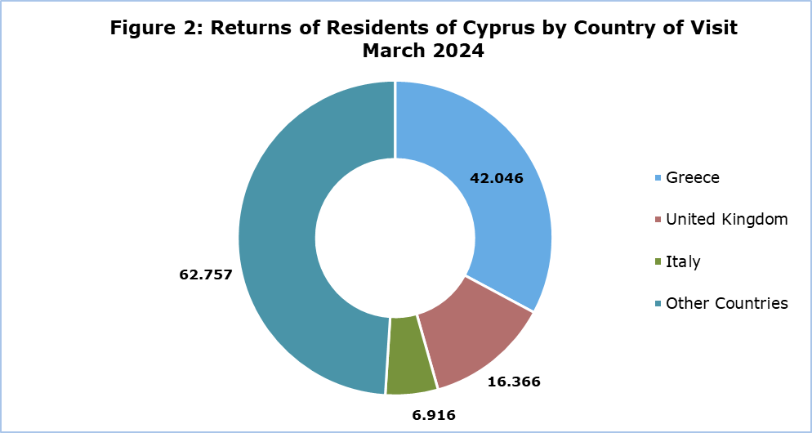

The purpose of travel for the residents of Cyprus in March 2024 was mainly holidays, with a percentage of 70,5%, whilst business reasons held a percentage of 19,7%, studies 8,4% and other reasons 1,4%.

**METHODOLOGICAL INFORMATION**

**Definitions**

**Tourists** – Visitors who stay for at least one night in Cyprus.

**Tourist arrivals** – The term refers to the number of trips and not to the number of persons. This differs in the sense that one person can take more than one trips during the reference period.

**Residents of Cyprus -** This category includes persons who have resided in Cyprus for at least 12 months or who have come to Cyprus with the intention of staying for at least 12 months, prior to their travel.

**Source of Data and Coverage**

The data are obtained from the Passengers Survey which is carried out at the points of arrival in Larnaka and Pafos airports. Additionally, data are also collected from administrative sources, such as the monthly arrivals from ports.

The data covers all persons who pass through passport control at the ports and airports in the Government controlled area of Cyprus. It does not include travelers who arrive and depart illegally via ports and airports in the occupied part of Cyprus.

The weighting was conducted based on the data sent to the Statistical Service by the Civil Aviation Department and from the ship manifests, as well as on the data sent by the Analysis and Statistics Office of the Cyprus Police.

***For more information:***

CYSTAT Portal, subtheme [Tourism](https://www.cystat.gov.cy/en/SubthemeStatistics?s=51)

[CYSTAT-DB](https://cystatdb.cystat.gov.cy/pxweb/en/8.CYSTAT-DB/8.CYSTAT-DB__Tourism__) (Online Database)

[Predefined Tables](https://www.cystat.gov.cy/en/KeyFiguresList?s=51) (Excel)

[Methodological Information](https://www.cystat.gov.cy/en/MethodologicalDetails?m=2172)

*Contact*

Lucy Panayidou: Tel.:+35722602152, E-mail: [lpanagidou@cystat.mof.gov.cy](mailto:lpanagidou@cystat.mof.gov.cy)