17 June, 2024

**PRESS RELEASE**

###### TOURIST ARRIVALS AND RETURNS OF RESIDENTS OF CYPRUS FROM TRIPS ABROAD: MAY 2024

**Tourist Arrivals 0,3% and Returns of Residents of Cyprus 13,8%**

**Tourist Arrivals**

The arrivals of tourists reached 421.400 in May 2024 compared to 420.076 in May 2023, recording an increase of 0,3%.

For the period of January – May 2024, arrivals of tourists totaled 1.170.214 compared to 1.156.705 in the corresponding period of 2023, recording an increase of 1,2%.

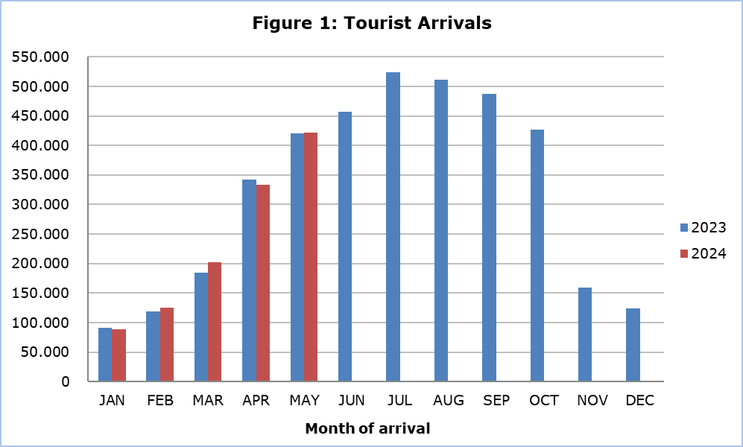

Arrivals from the United Kingdom were the main source of tourism for May 2024, with a share of 39,8% (167.696) of total arrivals, followed by Israel with 7,9% (33.138), Poland with 7,6% (31.849), Germany with 6,4% (27.081) and Sweden with 4,8% (20.103).

For a percentage of 83,7% of tourists, the purpose of their trip in May 2024 was holidays, for 9,8% visit to friends and relatives and for 6,3% business. Respectively, in May 2023, 82,1% of tourists visited Cyprus for holidays, 11,3% visited friends or relatives and 6,5% visited Cyprus for business reasons (Table).

|  |  |  |  |
| --- | --- | --- | --- |
| **Table** |  |  |  |
| **Purpose of Visit** | **Percentage (%)** | | |
| **May 2022** | **May 2023** | **May 2024** |
| Holidays | 79,5 | 82,1 | 83,7 |
| Visiting friends & relatives | 12,5 | 11,3 | 9,8 |
| Business | 7,9 | 6,5 | 6,3 |

**Returns of Residents of Cyprus**

A total number of 144.042 residents of Cyprus returned from a trip abroad in May 2024 compared to 126.583 in the corresponding month last year, recording an increase of 13,8%.

The main countries from which residents of Cyprus returned in May 2024 were Greece with a share of 32,8% (47.291), the United Kingdom with 9,9% (14.226) and Italy with 6,0% (8.660).

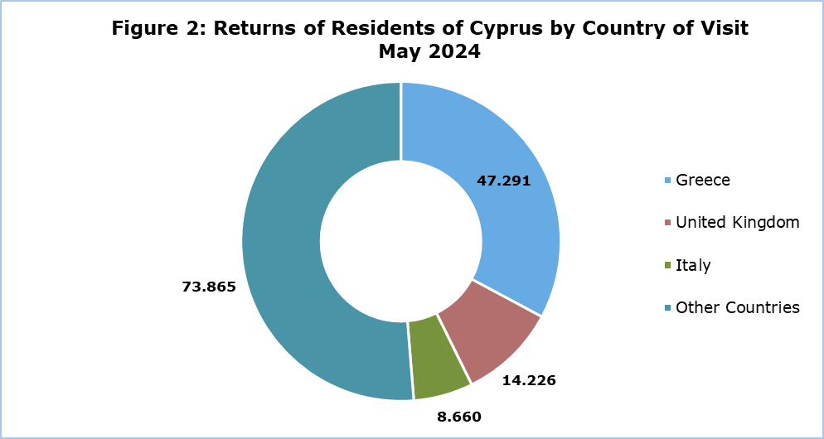

The purpose of travel for the residents of Cyprus in May 2024 was mainly holidays, with a percentage of 75,7%, whilst business reasons held a percentage of 17,8%, studies 5,0% and other reasons 1,5%.

**METHODOLOGICAL INFORMATION**

**Definitions**

**Tourists** – Visitors who stay for at least one night in Cyprus.

**Tourist arrivals** – The term refers to the number of trips and not to the number of persons. This differs in the sense that one person can take more than one trips during the reference period.

**Residents of Cyprus -** This category includes persons who have resided in Cyprus for at least 12 months or who have come to Cyprus with the intention of staying for at least 12 months, prior to their travel.

**Source of Data and Coverage**

The data are obtained from the Passengers Survey which is carried out at the points of arrival in Larnaka and Pafos airports. Additionally, data are also collected from administrative sources, such as the monthly arrivals from ports.

The data covers all persons who pass through passport control at the ports and airports in the Government controlled area of Cyprus. It does not include travelers who arrive and depart illegally via ports and airports in the occupied part of Cyprus.

The weighting was conducted based on the data sent to the Statistical Service by the Civil Aviation Department and from the ship manifests, as well as on the data sent by the Analysis and Statistics Office of the Cyprus Police.

***For more information:***

CYSTAT Portal, subtheme [Tourism](https://www.cystat.gov.cy/en/SubthemeStatistics?s=51)

[CYSTAT-DB](https://cystatdb.cystat.gov.cy/pxweb/en/8.CYSTAT-DB/8.CYSTAT-DB__Tourism__) (Online Database)

[Predefined Tables](https://www.cystat.gov.cy/en/KeyFiguresList?s=51) (Excel)

[Methodological Information](https://www.cystat.gov.cy/en/MethodologicalDetails?m=2172)

*Contact*

Lucy Panayidou: Tel.:+35722602152, E-mail: [lpanagidou@cystat.mof.gov.cy](mailto:lpanagidou@cystat.mof.gov.cy)