3 July, 2024

**PRESS RELEASE**

**RESULTS OF THE WHOLESALE AND RETAIL TRADE SURVEY 2022**

According to the results of the Wholesale and Retail Trade Survey, the main aggregates of the trade sector in 2022 registered a positive growth rate compared to 2021.

In particular, turnover in the broad trade sector increased in 2022 by 20,7% to €17.618,2 million compared to €14.598,3 million in 2021. At division level, in wholesale and retail trade and repair of motor vehicles and motorcycles turnover increased by 17,9% to €1.220,9 million, in wholesale trade by 28,7% to €9.073,0 million and in retail trade by 12,5% to €7.324,3 million.

Production value in 2022 reached €4.577,6 million, registering an increase of 16,8% over 2021.

In the whole of the trade sector, value added at current prices increased by 14,9% to €2.891,2 million in 2022 compared to €2.517,2 million in 2021. In wholesale and retail trade and repair of motor vehicles and motorcycles, value added increased by 20,6% to €263,5 million, in wholesale trade increased by 19,2% to €1.412,6 million and in retail trade increased by 9,1% to €1.215,1 million.

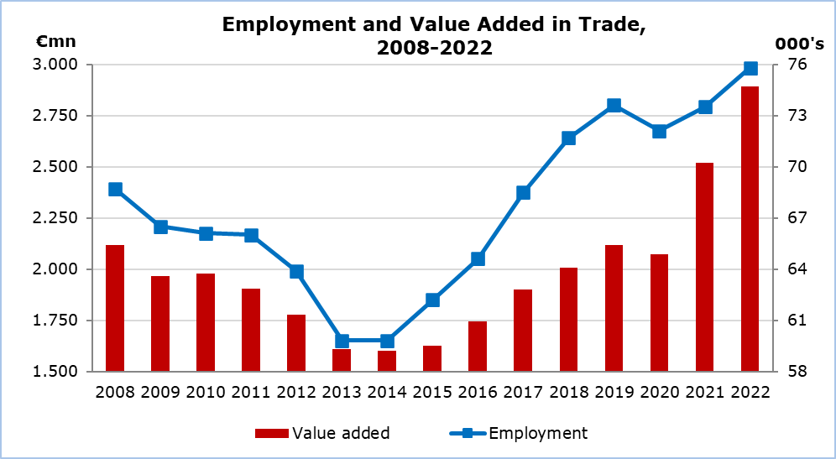

Employment in the trade sector increased in 2022 by 3,2% to 75,8 thousand compared to 73,5 thousand in 2021. In wholesale and retail trade and repair of motor vehicles and motorcycles employment reached 9,3 thousand, in wholesale trade 25,8 thousand and in retail trade 40,7 thousand persons.

|  |  |  |  |  |  |  |  |
| --- | --- | --- | --- | --- | --- | --- | --- |
| **Table** | | | | | | | |
| **NACE Rev. 2** | **Economic Activity** | **Main Aggregates 2022** | | | | | |
| **Turnover** | | **Value Added at Current Prices** | | **Employment** | |
| €mn | %* | €mn | %* | Number | %* |
| G | Wholesale and Retail Trade, Repair of Motor Vehicles and Motorcycles | 17.618,2 | 20,7 | 2.891,2 | 14,9 | 75.841 | 3,2 |
| 45 | Wholesale and Retail Trade and Repair of Motor Vehicles and Motorcycles | 1.220,9 | 17,9 | 263,5 | 20,6 | 9.287 | 1,8 |
| 46 | Wholesale Trade, except of Motor Vehicles and Motorcycles | 9.073,0 | 28,7 | 1.412,6 | 19,2 | 25.820 | 3,2 |
| 47 | Retail Trade, except of Motor Vehicles and Motorcycles | 7.324,3 | 12,5 | 1.215,1 | 9,1 | 40.734 | 3,5 |
| ***\* Annual percentage change of 2022 compared to 2021.*** | | | |  |  |  |  |

**METHODOLOGICAL INFORMATION**

**Definitions**

**Turnover** – Consists of all income arising during the reference period in the course of ordinary activities of an enterprise, and is presented net of all price reductions, discounts and rebates granted by it.

**Production value** – Derived by adding on turnover other income and changes in the value of stocks at the end of the year and deducting the cost of goods purchased for resale.

**Value added** **at current prices** - Derived by deducting from the production value the total cost of production expenses, administrative expenses and rents paid for buildings and machinery.

**Employment** – The total number of employees and self-employed persons.

**Coverage and Collection of Data**

The Wholesale and Retail Trade Survey covers a sample of around 2.250 enterprises with main activity falling under section G of the classification system of economic activities NACE Rev. 2 of the European Union, in particular divisions 45 (wholesale and retail trade and repair of motor vehicles and motorcycles), 46 (wholesale trade, except of motor vehicles and motorcycles) and 47 (retail trade, except of motor vehicles and motorcycles).

The collection of data by the Statistical Service is done by phone interviews, by email, by personal interviews and using administrative sources.

***For more information:***

CYSTAT Portal, subtheme [Wholesale and Retail Trade](https://www.cystat.gov.cy/en/KeyFiguresList?s=52)

[Predefined Tables](https://www.cystat.gov.cy/en/KeyFiguresList?s=52) (Excel)

[Methodological Information](https://www.cystat.gov.cy/en/MethodologicalDetails?m=2108)

*Contact*

Constantia Sergidi, Tel: +35722602237, Email: [ksergidi@cystat.mof.gov.cy](mailto:ksergidi@cystat.mof.gov.cy)