5 March, 2025

**PRESS RELEASE**

TURNOVER VALUE INDEX OF TRANSPORT AND STORAGE: **4th QUARTER 2024**

**Annual Change +2,2%**

The Turnover Value Index of Transport and Storage during the fourth quarter of 2024 reached 142,4 units (base year 2021=100), recording an increase of 2,2% compared to the corresponding quarter of the previous year.

By economic activity, increases relative to the fourth quarter of the previous year were observed in water transport (38,6%), in air transport (22,5%), in postal and courier activities (10,8%), in land transport (7,1%) and in warehousing and support activities for transportation (0,4%).

During the period January-December 2024, the Turnover Value Index of Transport and Storage recorded an increase of 1,6% compared to the corresponding period of 2023.

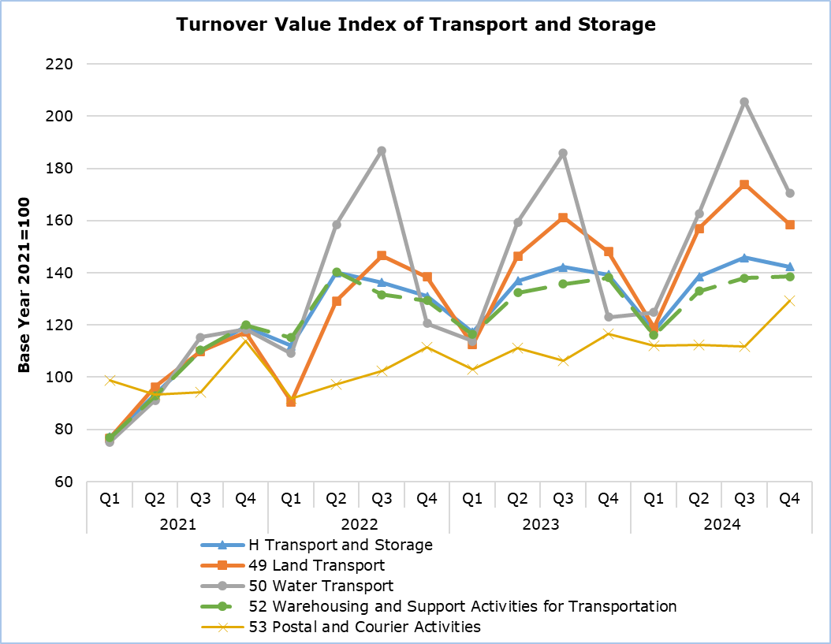

Note: The graph does not include NACE division 51 Air Transport.

|  |  |  |  |  |  |  |
| --- | --- | --- | --- | --- | --- | --- |
| **Table 1** |  |  | |  |  | |
| **Code NACE Rev. 2** | **Economic Activity** | **Turnover Value Index**  **(2021=100)** | |  | **Percentage Change (%)** | |
| **Oct-Dec 2023** | **Oct-Dec 2024** |  | **Oct-Dec 2024/2023** | **Jan-Dec 2024/2023** |
| **H** | **Transport and Storage** | **139,3** | **142,4** |  | **2,2** | **1,6** |
| 49 | Land transport and transport via pipelines | 148,0 | 158,5 |  | 7,1 | 7,1 |
| 50 | Water transport | 123,0 | 170,5 |  | 38,6 | 14,0 |
| 51 | Air transport | 377,6 | 462,4 |  | 22,5 | 0,1 |
| 52 | Warehousing and support activities for transportation | 138,1 | 138,6 |  | 0,4 | 0,6 |
| 53 | Postal and courier activities | 116,7 | 129,3 |  | 10,8 | 6,6 |

**METHODOLOGICAL INFORMATION**

**Scope and Coverage**

The purpose of the Turnover Value Index in Transport and Storage is to monitor short-term developments in activities classified under divisions 49 (land transport and transport via pipelines), 50 (water transport), 51 (air transport), 52 (warehousing and support activities for transportation, including the activity of ship-owning companies which have a physical presence in Cyprus) and 53 (postal and courier activities) of the Statistical Classification of Economic Activities of the European Union NACE Rev. 2.

**Data Collection**

The Statistical Service collects data monthly by telephone enquiries or e-mail, from a sample of enterprises active in the transport and storage sector.

**Compilation Method and Dissemination Practices**

The Index is using 2021 as the base year, meaning that it shows the quarterly changes in turnover in relation to the quarterly turnover average of the year 2021. In the base year, the average of the Turnover Index for the four quarters is 100,0. For example, a quarterly Turnover Index of 105,3 means that the Turnover for the specific quarter has increased by 5,3% in relation to the average quarterly turnover of 2021. The Index is calculated at current prices.

The Turnover Index is produced for the various divisions of the Statistical Classification of Economic Activities (NACE Rev. 2) that constitute the Transport and Storage sector. The aggregated sector index is a weighted average of the indices of the various divisions, as defined in NACE Rev. 2. The weights used are derived from the results of the annual Services and Transport Survey in the base year (2021) and reflect the share of turnover of each division in relation to the total turnover of the sector.

The compilation of the Index follows the provisions of Regulation (EU) 2019/2152 on European business statistics. The Index is transmitted to the Statistical Office of the European Union (Eurostat). In addition to gross data, both seasonally and calendar adjusted data are transmitted. The Index is published at national level only in its gross form.

***For more information:***

CYSTAT Portal, subtheme [Services](https://www.cystat.gov.cy/en/SubthemeStatistics?s=50)

[CYSTAT-DB](https://cystatdb.cystat.gov.cy/pxweb/en/8.CYSTAT-DB/8.CYSTAT-DB__Services__) (Online Database)

[Predefined Tables](https://www.cystat.gov.cy/en/KeyFiguresList?s=50) (Excel)

[Methodological Information](https://www.cystat.gov.cy/en/MethodologicalDetails?m=2312)

**Data for base year 2021=100 are available only in the CYSTAT-DB Online Database.**

*Contact*  
Andrie Milidoni: Tel: +357 22 602240, Email: [amilidoni@cystat.mof.gov.cy](mailto:amilidoni@cystat.mof.gov.cy)