30 April, 2024

**PRESS RELEASE**

SURVEY ON THE TRIPS OF RESIDENTS: **2022**

**Residents of Cyprus Participating in Domestic and Outbound Trips**

Residents participating in domestic trips for personal purposes decreased by 34,8% in 2022, reaching 161.489 compared to 247.804 in 2021.

The number of residents participating in outbound trips for personal purposes in 2022 amounted to 158.294, showing an increase of 110,5% compared to 75.204 residents who travelled abroad in 2021.

The following figure illustrates the fluctuations in the number of residents traveling within and outside Cyprus from 2016 onwards. During 2020 and 2021, mainly due to the spread of the coronavirus pandemic (COVID-19), the number of residents traveling abroad experienced a significant decrease whereas the number of residents traveling within Cyprus experienced a significant increase.

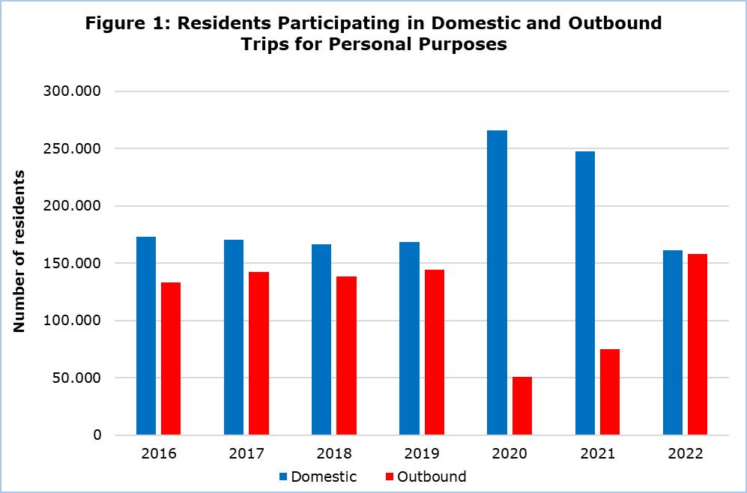

**Trips of Residents**

The number of domestic trips decreased by 9,7%, from 1.870.923 trips recorded in 2021 to 1.689.154 in 2022. A percentage of 98,5% of domestic trips were taken for personal purposes (i.e. leisure, recreation and holidays, visiting relatives and friends, health reasons, pilgrimage, etc.) and 1,5% for professional purposes. Rented accommodation such as hotels and similar establishments, campsites, hostels, etc., constituted the main type of stay for 48,6% of the trips, while non-rented accommodation (i.e. own home, staying with relatives or friends, etc.) accounted for 51,4%.

The number of trips abroad in 2022 reached 1.234.615 compared to 471.119 in 2021, recording an increase of 162,1%. A percentage of 86,4% of these trips were conducted for personal purposes while 13,6% for professional purposes. A percentage of 68,0% of outbound trips had rented accommodation as their main type of stay, while 32,0% had non-rented accommodation as their main type of stay.

**Expenditure for Trips**

Expenditure for domestic trips reached €266,5 mn in 2022, recording an increase of 2,0% compared to 2021. Expenditure on food and drinks in cafes and restaurants comprised the largest share of total expenditure for domestic trips (39,1%), while accommodation spending accounted for 32,9%. Transportation costs accounted for 11,9% of total expenditure and expenditure on other goods or services for 16,1%.

Expenditure for outbound trips amounted to €1.394,5 mn in 2022, recording an increase of 185,2% compared to 2021. Expenditure on transport comprised the largest share of total expenditure, with a percentage of 34,3%, while smaller percentages corresponded to expenditure on accommodation (24,3%), food and drinks in cafes and restaurants (22,2%) and other goods or services (19,2%).

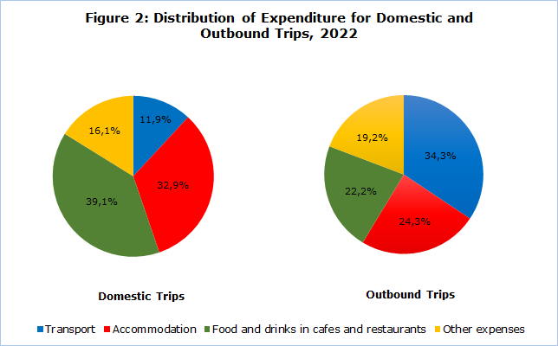

**METHODOLOGICAL INFORMATION**

**Definitions**

Residents - Persons who have resided in Cyprus for at least 12 months or who have come to Cyprus with the intention of staying for at least 12 months.

Trips - The term refers to the number of trips conducted by residents of Cyprus and not to the number of persons. This differs in the sense that one person can take more than one trips during the reference period.

Expenditure - Expenditure for a specific trip refers to individual expenses and may include expenditure for transport, accommodation, food and drinks in restaurants and cafes, purchases from supermarkets and kiosks, souvenirs, tickets for theaters, museums, sports activities, etc.

**Source of Data and Coverage**

The data is derived from the annual Survey on the Trips of Residents, covering all residents of Cyprus aged 15 and over. The sample selection is carried out using stratified random sampling, with the five districts and urban/rural areas as strata. A random sample of households is then selected within each stratum.

Data collection is conducted through telephone interviews using electronic questionnaires.

The survey is conducted in accordance with [Regulation (EU) 692/2011](https://eur-lex.europa.eu/LexUriServ/LexUriServ.do?uri=OJ:L:2011:192:0017:0032:EN:PDF) of the European Parliament and of the Council on European tourism statistics.

***For more information:***

CYSTAT Portal, subtheme [Tourism](https://www.cystat.gov.cy/en/SubthemeStatistics?id=51)

[CYSTAT-DB](https://cystatdb.cystat.gov.cy/pxweb/en/8.CYSTAT-DB/8.CYSTAT-DB__Tourism__) (Online Database)

[Methodological information](https://www.cystat.gov.cy/en/MethodologicalDetails?m=2294)

*Contact:*

Stavri Christou: Tel: +35725270621, E-mail: [schristou@cystat.mof.gov.cy](mailto:schristou@cystat.mof.gov.cy)