21 November, 2025

PRESS RELEASE

SURVEY ON THE TRIPS OF RESIDENTS: 2024

Residents of Cyprus Participating in Domestic and Outbound Trips

During 2024, 543.526 residents of Cyprus participated in at least one domestic or/and outbound trip that included a minimum of one overnight stay for personal purposes, recording an increase of 9,1% compared to 2023, during which a total of 498.026 persons have travelled domestically or abroad.

Residents participating only in domestic trips increased by 5,2% in 2024, reaching 164.590 compared to 156.510 in 2023.

The number of residents participating only in outbound trips amounted to 169.525, showing a decrease of 6,6% compared to 181.428 residents who travelled abroad in 2023.

Additionally, 209.411 persons participated in both domestic and outbound trips in 2024, recording an increase of 30,8% compared to 2023.

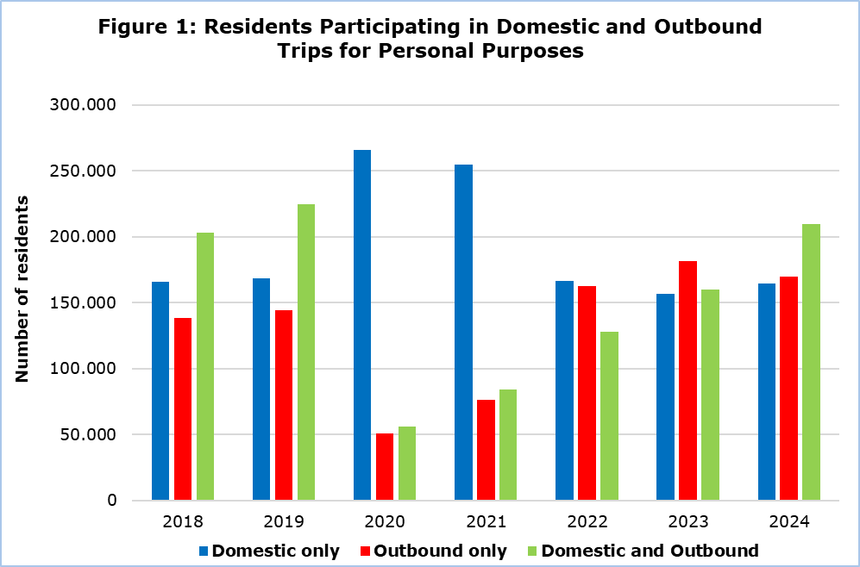

Trips of Residents

The number of domestic trips increased by 3,5%, from 1.564.359 trips recorded in 2023 to 1.619.371 in 2024. A percentage of 98,5% of domestic trips were taken for personal purposes (i.e. leisure, recreation and holidays, visiting relatives and friends, health reasons, pilgrimage, etc.) and 1,5% for professional purposes. Rented accommodation such as hotels and similar establishments, campsites, hostels, etc., constituted the main type of stay for 51,2% of the trips, while non-rented accommodation (i.e. own home, staying with relatives or friends, etc.) accounted for 48,8%.

The number of trips abroad in 2024 reached 1.747.492 compared to 1.674.725 in 2023, recording an increase of 4,3%. A percentage of 86,4% of these trips were conducted for personal purposes while 13,6% for professional purposes. A percentage of 72,7% of outbound trips had rented accommodation as their main type of stay, while 27,3% had non-rented accommodation as their main type of stay.

Expenditure for Trips

Expenditure for domestic trips reached €300,1 mn in 2024, recording an increase of 2,5% compared to 2023. Expenditure on accommodation comprised the largest share of total expenditure for domestic trips (37,4%), while food and drinks in cafes and restaurants spending accounted for 35,8%. Transportation costs accounted for 9,2% of total expenditure and expenditure on other goods or services for 17,6%.

Expenditure for outbound trips amounted to €2.070,9 mn in 2024, recording an increase of 6,7% compared to 2023. Expenditure on transport comprised the largest share of total expenditure, with a percentage of 34,8%, while smaller percentages corresponded to expenditure on food and drinks in cafes and restaurants (24,2%), on accommodation (23,6%), and other goods or services (17,4%).

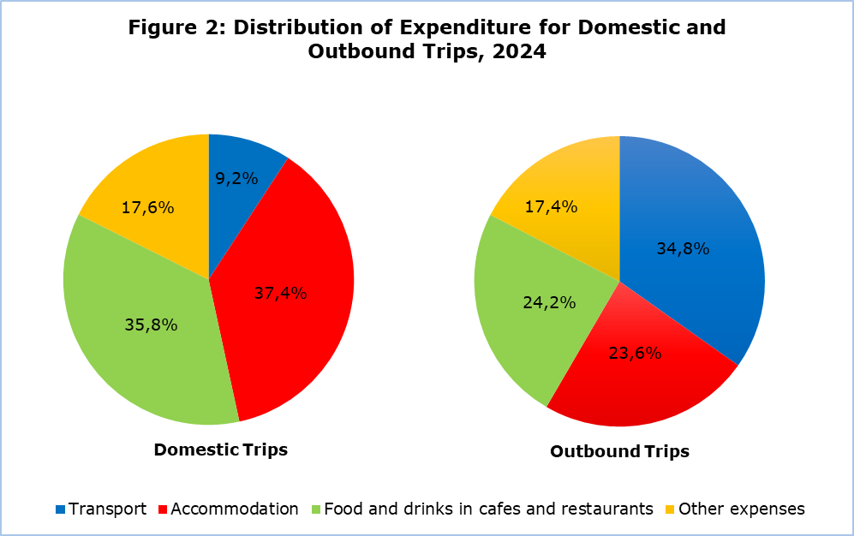

METHODOLOGICAL INFORMATION

Definitions

Residents - Persons who have resided in Cyprus for at least 12 months or who have come to Cyprus with the intention of staying for at least 12 months.

Trips - The term refers to the number of trips conducted by residents of Cyprus and not to the number of persons. This differs in the sense that one person can take more than one trips during the reference period.

Expenditure - Expenditure for a specific trip refers to individual expenses and may include expenditure for transport, accommodation, food and drinks in restaurants and cafes, purchases from supermarkets and kiosks, souvenirs, tickets for theaters, museums, sports activities, etc.

Source of Data and Coverage

The data is derived from the annual Survey on the Trips of Residents, covering all residents of Cyprus aged 15 and over. The sample selection is carried out using stratified random sampling, with the five districts and urban/rural areas as strata. A random sample of households is then selected within each stratum.

Data collection is conducted through telephone interviews using electronic questionnaires.

The survey is conducted in accordance with Regulation (EU) 692/2011 of the European Parliament and of the Council on European tourism statistics.

For more information:
CYSTAT Portal, subtheme Tourism
CYSTAT-DB (Online Database)
Methodological information

Contact:
Stavri Christou: Tel: +35725270621, E-mail: schristou@cystat.mof.gov.cy

