13 June, 2025

**PRESS RELEASE**

TURNOVER VALUE INDEX IN THE DIVISIONS OF WHOLESALE TRADE AND OF TRADE/REPAIR OF MOTOR VEHICLES: **1st QUARTER 2025**

**Annual change +4,8% in Wholesale Trade and +1,3% in Motor Vehicles**

The Turnover Value Index of Wholesale Trade (Division 46) during the first quarter of 2025 recorded an increase of 4,8% compared to the corresponding quarter of the previous year. For the same quarter, the Turnover Value Index of Sales and Repair of Motor Vehicles (Division 45) recorded an increase of 1,3% compared to the corresponding quarter of the previous year.

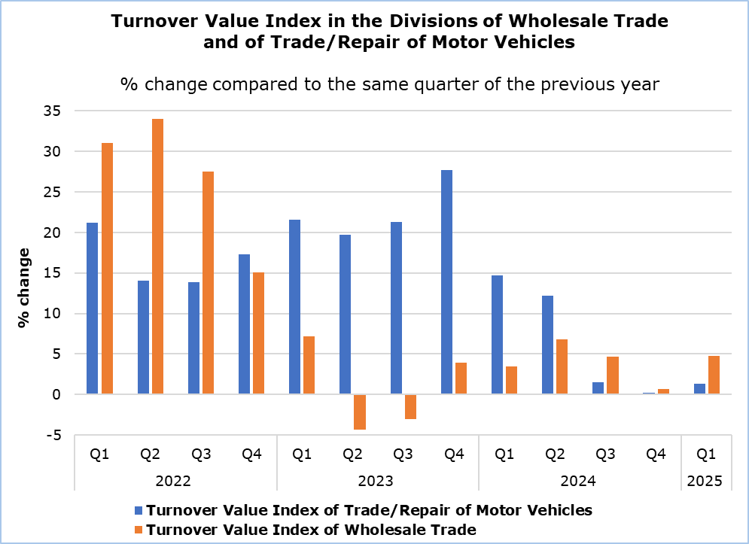

|  |  |  |  |  |  |
| --- | --- | --- | --- | --- | --- |
| **Table 1** |  |  |  |  | |
| **Code**  **(NACE**  **Rev. 2)** | **Economic Activity** | **Index (2021=100)** |  | **Percentage Change (%)** | |
| **Jan-Mar**  **2025** | **Jan-Mar 2025/2024** |  |
| 45.1 | Sale of motor vehicles | 175,4 |  | -3,1 |  |
| 45.2 | Maintenance and repair of motor vehicles | 136,8 |  | 6,9 |  |
| 45.3 | Sale of motor vehicles parts and accessories | 141,0 |  | 8,9 |  |
| 45.4 | Sale, maintenance and repair of motorcycles and related parts and accessories | 113,2 |  | 42,2 |  |
|  |  |  |  |  |  |
| **45** | **WHOLESALE AND RETAIL TRADE AND REPAIR OF MOTOR VEHICLES** | **158,2** |  | **1,3** |  |

|  |  |  |  |  |  |
| --- | --- | --- | --- | --- | --- |
| **Table 2** |  |  |  |  | |
| **Code**  **(NACE**  **Rev. 2)** | **Economic Activity** | **Index (2021=100)** |  | **Percentage Change (%)** | |
| **Jan-Mar**  **2025** | **Jan-Mar 2025/2024** |  |
| 46.1 | Wholesale on a fee or contract basis | 147,2 |  | -7,9 |  |
| 46.2 | Wholesale of agriculture raw materials and live animals | 89,0 |  | 1,6 |  |
| 46.3 | Wholesale of food, beverages and tobacco | 120,2 |  | 6,8 |  |
| 46.4 | Wholesale of household goods | 147,0 |  | 12,4 |  |
| 46.5 | Wholesale of information and communication equipment | 117,3 |  | -4,1 |  |
| 46.6 | Wholesale of other machinery, equipment and supplies | 129,3 |  | 7,1 |  |
| 46.7 | Other specialized wholesale | 125,9 |  | -0,1 |  |
| 46.9 | Non-specialized wholesale trade | 128,7 |  | 4,6 |  |
|  |  |  |  |  |  |
| **46** | **WHOLESALE TRADE, EXCEPT OF MOTOR VEHICLES** | **128,7** |  | **4,8** |  |

**METHODOLOGICAL INFORMATION**

**Scope and Coverage**

The purpose of the Turnover Value Indices is to monitor short-term developments classified under Divisions 45 (Sales and Repair of Motor Vehicles) and 46 (Wholesale Trade) of the Statistical Classification of Economic Activities of the European Union NACE Rev.2. Turnover comprises the total amounts invoiced by an enterprise during the reference period and this corresponds to the market sales of goods and services, excluding VAT but including other duties and taxes on the goods.

**Data Collection**

The Statistical Service collects data monthly by telephone enquiries or e-mail. Data collection starts five days after the end of the reference period and is usually completed within forty-five days.

**Compilation Method and Dissemination Practices**

The Indices are using 2021 as the base year, meaning that they show the quarterly changes in Turnover in relation to the quarterly Turnover average of the year 2021. In the base year, the average of the Turnover indices for the four quarters is 100,0. For example, a quarterly Turnover index of 105,3 means that the Turnover for the specific quarter has increased by 5,3% in relation to the average quarterly Turnover of 2021. The Indices are calculated at current prices.

The aggregated Indices are a weighted average of the Turnover indices of the various Groups (subsets of activities within the Division), as defined in NACE 2. The weights used are derived from the results of the annual Wholesale and Retail Trade Survey in the base year (2021) and reflect the share of Turnover of each Group in relation to the total turnover of the activities of the Division.

The compilation of the Indices follows the provisions of Regulation (EU) 2019/2152 on European business statistics. The Indices are transmitted to the Statistical Office of the European Union (Eurostat). In addition to gross data, both seasonally and calendar adjusted data are transmitted. The Indices are published at national level only in their gross form.

***For more information:***

CYSTAT Portal, subtheme [Trade](https://www.cystat.gov.cy/en/SubthemeStatistics?s=52)

[CYSTAT-DB](https://cystatdb.cystat.gov.cy/pxweb/en/8.CYSTAT-DB/8.CYSTAT-DB__Trade__Wholesale) (Online Database)

[Predefined Tables](https://www.cystat.gov.cy/en/KeyFiguresList?s=52) (Excel)

[Methodological Information](https://www.cystat.gov.cy/en/MethodologicalDetails?m=2296)

**Data for base year 2021=100 are available only in the CYSTAT-DB Online Database.**

*Contact*

Evangelia Efstathiou: Tel.: 22602196, E-mail: eefstathiou@cystat.mof.gov.cy